Let’s take a tour through the Bible to see God’s attitude toward the nations throughout history. He has desired to call people from all nations to worship Him.
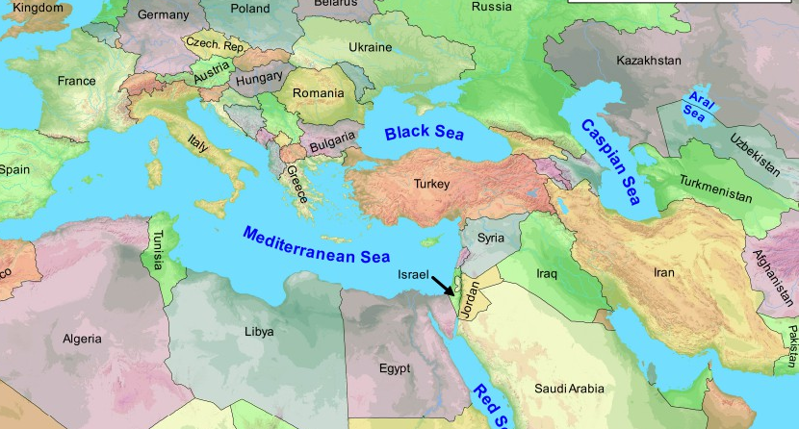
Read Genesis 12:1-3.
- Looking at this map, what do you think is significant about its location?
- What was God’s plan in doing this?
- What does God promise to Abraham about the whole earth?

Read Isaiah 49:5-6. What does God say is the scope of His goal of salvation?

Read Matthew 28:18-20. How do you see this command as applying to each of us today?

Read Acts 1:8. How close are we to fulfilling this prophecy? What do we have today to help us complete the task? What is still missing?

The only thing that will go on into eternity from this planet will be the souls of men and women. God will make a new Heaven and a new Earth, but souls from all nations will live on for all eternity (Revelation 5:9). We can be a part of what God is doing in the world - guaranteed. His plan will come to pass and we can get in on the great adventure of partnering with God to accomplish His world-wide vision. Being a part of what He is doing gives our souls a sense of destiny. It’s what we were made for!

How to Get in on What God Is Doing
How might we be a part of reaching people in other nations? In what ways can we make a difference?” Below are several “bridges” to the world.
- Praying
- Giving
- Going
- Sending Others

NEXT STEPS
- Which bridge to the world do you want to take right now? Which “going” opportunity would help you develop your world vision?
- Look at and pray over a world map and ask the Lord to use your ministry to influence other parts of the world. Pray for at least one specific country.
- Read a missionary biography to further educate yourself and be captured by God’s heart for the world.

