Text in blue is found only in the Leaders Guide.
In this lesson your challenge is to help your group see and understand God’s heart for the whole world, not just your immediate vicinity. God’s desire, consistently revealed throughout Scripture, is that all people in all the earth would know about Him; He will not rest until His glory is evident among all people.
You get to motivate your group to be a part of what God is doing throughout the world, so he will have the pleasure of participating with our Lord in the worldwide harvest. Pray that God would use this survey to awaken in them a desire to participate in the Great Commission, anywhere in the world.
Let’s take a tour through the Bible to see God’s attitude toward the nations throughout history. He has desired to call people from all nations to worship Him.

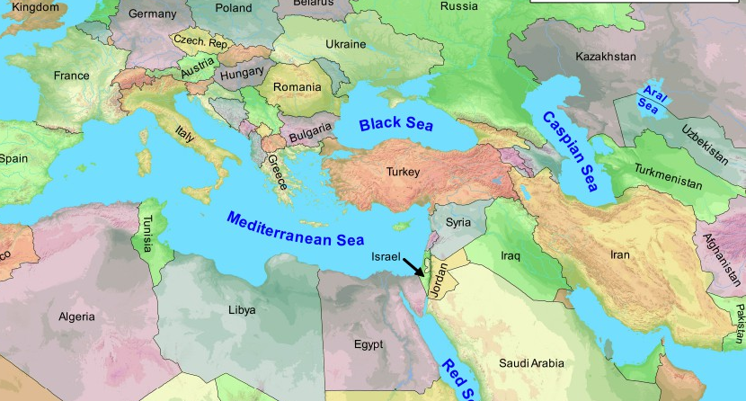
Read Genesis 12:1-3.
- Looking at this map, what do you think is significant about its location?

It is the center of the world on the thruway between Europe, Asia and Africa.

- What was God’s plan in doing this?

To make them a light to all nations.

- What does God promise to Abraham about the whole earth?

In Abraham all families of the earth would be blessed, referring to the Messiah. Galatians 3:8 shows how Jesus is the fulfillment of this promise.

Read Isaiah 49:5-6. What does God say is the scope of His goal of salvation? The ends of the earth.

Read Matthew 28:18-20. How do you see this command as applying to each of us today?

Every one of us has a responsibility to spread the gospel until He returns.

Read Acts 1:8. How close are we to fulfilling this prophecy? What do we have today to help us complete the task? What is still missing?

We have the technology, money, training, and strategy. The greatest need is still the laborers who are willing to fully engage in God’s purposes, submit their agenda to His, and be willing to do whatever He asks of them to fulfill His plan.

The only thing that will go on into eternity from this planet will be the souls of men and women. God will make a new Heaven and a new Earth, but souls from all nations will live on for all eternity (Revelation 5:9). We can be a part of what God is doing in the world - guaranteed. His plan will come to pass and we can get in on the great adventure of partnering with God to accomplish His world-wide vision. Being a part of what He is doing gives our souls a sense of destiny. It’s what we were made for!

How to Get in on What God Is Doing
How might we be a part of reaching people in other nations? In what ways can we make a difference?” Below are several “bridges” to the world.
- Praying - Pray for specific people groups or nations, for individuals you know who are laboring overseas. Operation World is a great prayer guide you could use.
- Giving - Ask them, “Do you give any money to a cause right now?” They may not have much to give, but they can tithe from summer earnings and establish a habit of giving that will continue after they graduate.
- Going - Ask them if they’ve ever considered going on a mission trip. Check out this list of opportunities with Cru.
- Sending Others - If folks from your group don’t go themselves, they can disciple and support others who will. Talk about how they can be used to motivate people to go to the world.

NEXT STEPS
- Which bridge to the world do you want to take right now? Which “going” opportunity would help you develop your world vision?
- Look at and pray over a world map and ask the Lord to use your ministry to influence other parts of the world. Pray for at least one specific country.
- Read a missionary biography to further educate yourself and be captured by God’s heart for the world.

