Read Colossians 3:1-4. In light of our position in Christ, being with Him in the heavenly places, what does Paul exhort us to do and not do? Why does Paul urge us to focus on things above?

Consider a line representing eternity – infinite in both directions – how would you represent your 70 years on earth on that line, a dot?
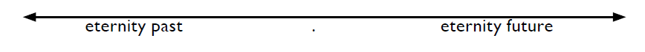
We must consider how we will invest our lives – for the dot or for eternity?

Consider these three future things we can look forward to:

- We will share in His glory. (Phil. 2:9-11)
- This future reality helps us endure suffering today. (Rom. 8:18 and 2 Cor. 4:17)
- Heavenly rewards for actions today. (2 Cor. 5:9-10, 1 Cor. 4:5, Matt. 25:14-30)

In light of the brevity of life and all that lies ahead in eternity:
- Where are you setting your mind at this time in your life? Why? Why is it so difficult to keep our mind on things above (on the line instead of the dot)?
- Are there any changes you need to make to live more for eternity in your everyday life (in what you value, how you spend your time or your priorities)?
- When you look back on your life, what things will you want to have accomplished or been true of you? How do you want to be remembered?
- How can even the temporal things we do be done in such a way as to gain eternal reward?

NEXT STEPS
Here are a few application suggestions:
- Study the topic of the Judgment Seat of Christ found in 2 Cor. 5 & 1 Cor. 3:10-15.
- Read and reflect on Matt. 24 & 25.
- Visit a cemetery and look over tombstones. Note what people said about life, and reflect and pray over the brevity of life, especially a life not lived in light of eternity.

