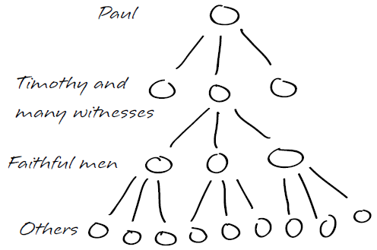
You can reach thousands of people for Jesus, but not through simple addition. If you reached one person every month for the next 20 years, you would have introduced 240 souls to Christ, a fruitful witness seen by very few Christians. However, if you were to disciple each of those 240 new believers so that they in turn would win and disciple others, generation after generation, many millions would be introduced to Christ in the same number of years. This is what we mean by “spiritual multiplication.” Two people multiplied just 32 times equals the population of the entire world!
Biblical Basis for Multiplication
Read Mark 3:13-15. Why did Jesus choose a small group of men to walk with Him closely? What did He do with them that He didn’t do with the masses?
While Jesus was still on earth, His ministry actually grew from 12 to the 70, and there were 120 praying in the upper room after His death and resurrection. After Pentecost in Acts 2, 3000 joined the new body of believers. Multiplying leadership was Jesus’ primary strategy to establish the Church.
Read Acts 16:1-3 and 1 Thessalonians 2:8. What was Paul’s discipleship curriculum?
Read 2 Timothy 2:1-2.
- How many generations of leaders does Paul speak of?
- What two qualifications does Paul say these men must have in order for Timothy to invest his life into them? What does that look like?
Summary
The church is thriving today all over the world because Jesus and the apostles discipled faithful men and women, and spiritual leaders for the past 2000 years have done the same. You can get in on the pleasure and fulfillment of multiplying your life into others. In fact, we can reach the world through multiplication.
NEXT STEPS
Do you think you are ready to begin multiplying your life? Is there someone you could begin to disciple? How about beginning to lead a Bible study and seeking to raise up potential disciples? Is the timing right for that?

