In this lesson, your focus is on motivating your group to want to multiply their life into the lives of others; to help them understand the Biblical principle of multiplication - how a movement or church grows through leaders reproducing other leaders; and to challenge them to begin looking for someone to disciple.
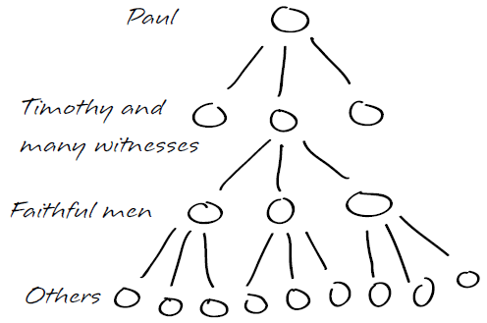
You can reach thousands of people for Jesus, but not through simple addition. If you reached one person every month for the next 20 years, you would have introduced 240 souls to Christ, a fruitful witness seen by very few Christians. However, if you were to disciple each of those 240 new believers so that they in turn would win and disciple others, generation after generation, many millions would be introduced to Christ in the same number of years. This is what we mean by “spiritual multiplication.” Two people multiplied just 32 times equals the population of the entire world!
Biblical Basis for Multiplication
Read Mark 3:13-15. Why did Jesus choose a small group of men to walk with Him closely? What did He do with them that He didn’t do with the masses?
- These were ones He had with Him almost all of the time. He taught them, spent time with them, and ministered to others with them. They learned by being with Him, they caught His heart, vision, and passion. He poured His life into them to the end so that they would give leadership to the Church after He was gone. They would carry on the work of the Kingdom. His whole strategy rested on these 12 men.
While Jesus was still on earth, His ministry actually grew from 12 to the 70, and there were 120 praying in the upper room after His death and resurrection. After Pentecost in Acts 2, 3000 joined the new body of believers. Multiplying leadership was Jesus’ primary strategy to establish the Church.
Read Acts 16:1-3 and 1 Thessalonians 2:8. What was Paul’s discipleship curriculum?
- He developed leaders for the church by taking men with Him and teaching, training, and imparting His life to them. Paul always had young potential spiritual leaders with Him on His missionary journeys. He also wrote letters (like I and II Timothy) to give further instructions on how to be a leader.
Read 2 Timothy 2:1-2. How many generations of leaders does Paul speak of?
- Four generations. Paul discipled Timothy who discipled faithful men, and these faithful men discipled other faithful men.
What two qualifications does Paul say these men must have in order for Timothy to invest his life into them? What does that look like?
- Faithful - He had to know that they could be depended upon to follow through with what he entrusted to them. Otherwise, the church would eventually weaken and die. This remains true today. You need to wisely discern if someone you want to disciple is going to be faithful with what you pass on to them; otherwise, your ministry will not multiply. How can you know if they will be faithful? Are they faithful to come to Bible Study or appointments? Are they available when you give them opportunities to grow and serve, e.g., attend a retreat or conference, come along with you sharing your faith? Are they dependable with the ministry responsibilities they are given?

- Able to teach others – This requires 2 things:
  - Spiritual maturity – This is not a measurable sin/holiness ratio or the amount of Bible knowledge they have. It is about the posture of their heart toward God. Is it their true desire to keep God front-and-center and on the throne of their lives? Also, are they able to apply the Bible to their lives in such a way that others learn?
  - Social or emotional maturity - Can they relate well enough so that others want to learn from them? All of us have problems, and issues of growth in our lives, but the emotionally maturing person is growing and able to trust the Lord with these areas of need so they are able to give to others and be involved in someone else’s life.
Summary
The church is thriving today all over the world because Jesus and the apostles discipled faithful men and women, and spiritual leaders for the past 2000 years have done the same. You can get in on the pleasure and fulfillment of multiplying your life into others. In fact, we can reach the world through multiplication.
NEXT STEPS
Do you think you are ready to begin multiplying your life? Is there someone you could begin to disciple? How about beginning to lead a Bible study and seeking to raise up potential disciples? Is the timing right for that?

