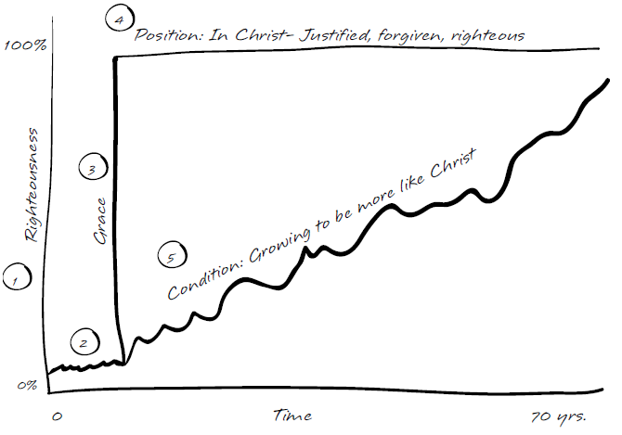
Before we knew Christ:
Take a look at Ephesians 2:1-3. What was true of us in our position in Adam before Christ? List and discuss some things here.

When Christ came into our lives:

Read Ephesians 2:4-7. What motivated God to take action on our behalf?

What did God do for us at salvation?
On what basis did He do it? What does His action in saving us display to the world?
Now that we are in Christ:
What is true of us now according to Rom 5:1-2; Heb 10:11-18 and 2 Cor 5:21?
Our Daily Condition:
Though we are “considered” perfect in Christ, we obviously are not perfect in our daily condition. When we trusted Christ, He also began the life-long work of making our lives look more and more like His. Phil. 2:12-13 and 3:12-14 are just a couple of the many exhortations to pursue growth and maturity.
Summary – Living out Our Position:
The primary emphasis of this lesson is who we are in Christ and the fact that God wants us to see ourselves “in Christ” and focus on our position, not our condition. The enemy wants the opposite, for us to focus on what we’re doing (or failing to do) to “earn” God’s love, bouncing us between guilt, pride and confusion. God’s love and acceptance toward us has always been based on grace (unmerited favor) because of what Jesus did for us. We have not earned it nor will we ever deserve His love based on our spiritual performance (no matter how righteous we act or how little we sin). Spiritual disciplines (like prayer, Bible study, worship, etc) help us get to know God better, but not to gain favor and right standing with God, which is already ours forever.
NEXT STEPS:
1. What are some ways that you try to earn right standing before God?
2. How have you seen God change your behavior toward matching your position?
3. Why do you think God does this through a process? What is gained?

