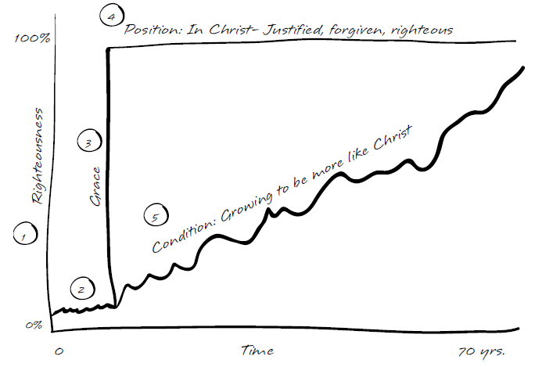
Text exclusive the leader’s guide marked in blue.
Your objective in this lesson is to help your group internalize that their position and identity is secure because of what Christ has done and is not based on the daily condition of their life.

1.) Growing in Christ

The vertical axis of the diagram shows your growth in righteousness, while the horizontal marks the passage of time over your life.

2.) Before we knew Christ.

Take a look at Ephesians 2:1-3. What was true of us in our position in Adam before Christ? List and discuss some things here.

- Spiritually dead (no life of God within us), enslaved to sin.
- Walked according to the world, flesh, and the devil.
- We were children of wrath (confer John 3:36).
- Rom. 5:12-19 - death, judgment, condemnation, made sinners.

3.) When Christ came into our lives.

Read Ephesians 2:4-7. What motivated God to take action on our behalf?

- His love and mercy.

What did God do for us at salvation?
- He made us alive with Christ.
- He raised us up with Him.
- He seated us with Him in the heavenly places.
On what basis did He do it?
- By grace, not because we deserved it, not based on our merit.
- Grace means unmerited favor - “even when we were dead.”
What does His action in saving us display to the world?
- The surpassing riches of His grace.
4.) Now that we are in Christ.
What is true of us in the following passages since we are in Christ?
Romans 5:1-2
- We are justified, declared not guilty, standing in grace.
Hebrews 10:11-18
- We have complete forgiveness, and perfect standing before God.
2 Corinthians 5:21
- We are righteous before God with the righteousness of Christ.
5.) Our Daily Condition
Though we are “considered” perfect in Christ, we obviously are not perfect in our daily condition. When we trusted Christ, He also began the work of making our lives look more and more like His. This is a life-long process that involves several spiritual disciplines that God has given us to help us grow and mature. Phil. 2:12-13 and 3:12-14 are just a couple of the many exhortations to pursue growth and maturity.
Summary – Living out Our Position
The primary emphasis of this lesson is who we are in Christ and the fact that God wants us to see ourselves “in Christ” and focus on our position, not our condition. The enemy wants the opposite, for us to focus on what we’re doing (or failing to do) to “earn” God’s love, bouncing us between guilt, pride and confusion. God’s love and acceptance toward us has always been based on grace (unmerited favor) because of what Jesus did for us. We have not earned it nor will we ever deserve His love based on our spiritual performance (no matter how righteous we act or how little we sin). Spiritual disciplines (like prayer, Bible study, worship, etc) help us get to know God better, but not to gain favor and right standing with God, which is already ours forever.
NEXT STEPS:
1. What are some ways that you try to earn right standing before God?
2. When do you doubt God’s love and acceptance of you?
3. When you sin, instead of claiming God’s forgiveness and acceptance by faith based on His grace, what are some things you do to try to work your way back into believing that God loves and accepts you?
4. In what ways have you begun to see God change you in practice toward what you already are positionally?
5. Why do you think God does this through a process? What is gained?

