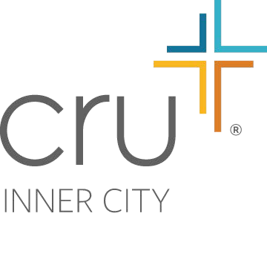

CHICAGO
Agape Community Center

September 26, 2006
342 West 111th Street Chicago, IL 60628 Phone (773) 821-7060 Fax (773) 821-0764

Dear <enter name>,

You have been listed as a reference for <enter name> who is applying to become a volunteer at the Agape Community Center. The Agape Community Center offers Christian-based programming to families on the Southside of Chicago. In an effort to protect our participants, staff, and the volunteers themselves, we have an established policy to screen everyone who desires to serve at our facility.

Volunteers at the Agape Center are in close contact with children, youth, and/or adults from a variety of situations. Some may have even struggled with life controlling problems. We desire to be as certain as possible that these relationships between program participants and volunteers will be healthy ones. We would appreciate your assistance in helping us determine this person’s suitability as a volunteer.

Please fill out the enclosed reference form as thoroughly as possible. If you do not feel qualified to answer a particular question, please state so. Please return the form in the sealed envelope provided to ensure confidentiality. This form will not be shared with the volunteer applicant. In order to serve as a volunteer, we will need to have this form in our records no later than <enter date>.

If you have any questions or concerns, feel free to contact me at 773-821-7060 at your earliest convenience. I appreciate your cooperation!

Sincerely,

<enter name>
<enter title>

THE INNER CITY MINISTRY OF CRU®

