For Children in the Neighborhood

The following is a practical guide to assist your church in organizing an Easter outreach for children in your community to introduce them to Jesus. This is meant to be an aid, not a mandate for your ministry. Feel free to add, make changes, or delete material. These ideas can be used for any outreach during the year.
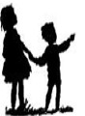

National Office
2112 Broadway St. NE, Suite 100
Minneapolis, MN. 55413.

Phone: (612)-338-0999

Page 1 of 63 Revised: 08/06/2014

TABLE OF CONTENTS

1. -Purpose of the Easter Bag ..................................................................... Page 4

2. Job Assignments...................................................................................... Page 5
Director, Prayer Coordinator, Administrator, Game Coordinator, Food Coordinator, Sharing the Gospel Coordinator, Music Coordinator, Follow-up Coordinator

3. Sample Schedules .................................................................................. Page 10
Sample Schedule for 2 hours Easter Outreach Party ...............................Page 10 Sample Schedule if using the Jesus Video ..............................................Page 11

4. Welcome activities..............(choose one).............................................. Page 12
1. Celebration Shaker...............................................................................Page 12
2. “Cross” bookmarker ............................................................................Page 13
3. Jesus Arise ...........................................................................................Page 14
- Take up your cross and follow me – color page ..................................Page 16
- Take up your cross and follow me – vocabulary word sheet ..............Page 17
- Take up your cross and follow me – unscramble words .....................Page 18 7. Take up your cross and follow me – maze ..........................................Page 19 8. Egg Mosaics.........................................................................................Page 20 9. Bird Nest Cupcakes .............................................................................Page 20 10. Mixer Game ......................................................................................Page 21
11. Face painting (no content)

5. Games..................................(choose a couple of games) ...................... Page 22
1. Plastic Egg Roll Race ..........................................................................Page 22
2. Egg Carried In a Spoon Race...............................................................Page 22
3. A Tricky Spoonful ...............................................................................Page 22
4. Burlap Sack Race.................................................................................Page 22
5. Race Stepping on Egg Shaped Cardboard ...........................................Page 23 6. Tri-Hop-Athon .....................................................................................Page 23
7. Duck Walk Race ..................................................................................Page 23
8. Three Legged Race ..............................................................................Page 23
9. Across the Great Divide Game ............................................................Page 24
10. Rock, Paper, Scissors Tag .................................................................Page 24
11. Elbow Tag..........................................................................................Page 24
12. Memory Verse Practice and Relay Race ...........................................Page 25

Turn to the verses in the order written down. It is helpful if you have the first verse written in the front of your Bible to remind you where to start. After reading a verse, have the following verse written in the margin to tell you where to go next. With each verse, ask the person to read the verse and tell you what it means. Then move on to the next verse. You do not have to add anything. You can let Scripture speak for itself.

Example:
You say: “Read this verse aloud.” Person: Reads the verse aloud.
You say: “What does the verse say to you?”
Person: Answers correctly. (Have them reread it if the answer is not correct, maybe pointing out a few words.)
You turn to the next verse and repeat the process.

Bible verses to look up with the person: Romans 3:23
Romans 6:23
John 3:3 Ask the question, “Based on what we have read so far, why did Jesus have to die?” John 14:6
Romans 10:9-11
2 Corinthians 5:15
Revelation 3:20

After they explain the verse.
You ask, “Are you ready to invite Jesus into your heart and life?”

If yes:
Say a prayer line by line and have them repeat each line after you:
“Heavenly Father, I have sinned against you. I want forgiveness for all my sins. I believe that Jesus died on the cross for me and rose again. Father, I give you my life to do with as you wish. I want Jesus Christ to come into my life and into my heart. This I ask in Jesus’ name. Amen.”

Page 2 of 63 Revised: 02/09/2009
Page 63 of 63 Revised: 2/15/2008

Easter Egg Extravaganza Community Survey

This is a very simple way to get children involved in evangelism. (These could be the children in children’s church or a Sunday school class.) Ask them about a month before Easter what friends of theirs are not involved in a church. Each child is assigned to find two or three kids a month before Easter. These kids could be from the same family. The week before Easter, assign adults from the church to go with the children from the class. They will take Easter bags to the homes of the children’s friends that were recommended. The children can pray and keep the younger children occupied while the adult can share a community survey with the adult of the household they are in. The adult introduces him/herself. The kids know each other, so it is a natural transition.

Here are the four community survey questions:

- What is the biggest problem in the community or neighborhood?

- What do you think is the reason people attend church or a religious group?

- To what groups do you think the church needs to give more attention?
  - Preschool
  - Children
  - Youth
  - Young Adults
  - College
  - Senior Citizens
  - Other

- What do you think it takes for a person to go to heaven?
  - Faith answer – Jesus paid for our sins
  - Don’t know/doubt
  - Works

Do not give them the answers, but listen to them and see which category they fall under. Then depending on their answer you can say, “May I share with you how the Bible answers these questions?” (Can use a gospel tract or the Bible*.)

You engage the children to pray and keep little ones quiet. Before you leave, give the children the Easter bags and show them what is inside. If you have included a children’s tract, then you ask the parents if they will read it to their children.

Procedure in how to share the gospel using the Bible, from “Sharing Jesus Without Fear”, by William Fay.
Table of Contents

6. Skits .....................................(choose one).............................................. Page 27
1. Trying To Bridge the Gulf ...................................................................Page 27
2. Trying To Mold Jesus into What You Want .......................................Page 27
- Crossing the Great Divide (skit) Page 28

7. Methods of Sharing the Gospel............................................................. Page 29
  - Choose one of these six methods to share the Gospel message:
1. Resurrection Eggs .........................................................................Page 29
2. Good News Bracelet .....................................................................Page 33
3. Folded Paper stories......................................................................Page 36
Easter – Jesus and the 2 Criminals ........................................Page 36
Three boys – Ticket to Heaven ..............................................Page 39 4. Four Circles ..................................................................................Page 41
5. Jesus Video for Children ..............................................................Page 44
6. Your own method that is appropriate for children

  - Example of The ABC Child Evangelism Good News Tract ..............Page 45

  - Crafts (Included in the gospel message section)
Good News Bracelets ........................................................................Page 33
Folded paper stories ...........................................................................Page 36
Four circles ........................................................................................Page 41

8. Follow-up ideas...................................................................................... Page 46

9. Appendix ................................................................................................ Page 47
“Promise” commitment cards ............................................................Page 48
Clarifying questions to check for understanding ...............................Page 49
Visual of the “Folded Paper” Gospel Message..................................Page 51 English beaded bracelet tract .............................................................Page 52
Spanish beaded bracelet tract.............................................................Page 53 Large colored dots for the Beaded Bracelet Gospel message............Page 54 Checklist of what to bring to the outreach.........................................Page 60 Easter Outreach Event Worksheet/Job Assignments.........................Page 61
Easter Egg Extravaganza Community Survey...................................Page 62

Page 62 of 63 Revised: 2/15/2008

Page 3 of 63 Revised: 02/09/2009

PURPOSE OF EASTER OUTREACH PARTIES
For Children in the Neighborhood

The Purpose: To provide a simple, effective, fun way to be able to:
  - connect with non-churched or unsaved children and their families.
  - lead children to a personal relationship with Jesus Christ.

Why?
  - Children are in the age group that is most receptive to the gospel.

  - Of a group of 4 to 13 year olds, 32 out of every 100 will respond positively to a call to receive Christ. This number drops to only 4 out of 100 teenagers, and only comes up to 6 out of 100 adults. (Barna Research Group)

  - By the year 2010 half of the world’s population will be under the age of 18.

  - Today only 20 percent of the children in America go to church. We need to reach out to the other 80 percent.

  - Why not help these children prepare for eternity when they are young – with most of their lives still in front of them?

Prayerfully consider whom you will invite, the timing of your event, and when most children are available. (A suggestion: Easter Sunday is not the best day to do a separate outreach party, as there are too many other things going on.)

Primary age group for the outreach is 6 – 12 year olds (elementary school age children).
Easter Outreach Event Worksheet
Type of Outreach: (i.e. party, picnic, community survey)

Location: Date:
Time: Gospel Presentation Method:
Job Assignments:
Director: Prayer Coordinator: Administrator: Game Coordinator: Music Coordinator: Food Coordinator:
Sharing the Gospel Coordinator: (This person will share the Gospel to the whole group of students as well as oversee the small group leaders.)

Small Group Leader: _ Small Group Leader: _ Small Group Leader: _ Small Group Leader: _ Small Group Leader: _ Small Group Leader: _ Small Group Leader: _ Small Group Leader: _ Small Group Leader: _ Small Group Leader: _

Follow-Up Coordinator:

Page 4 of 63 Revised: 02/09/2009

Page 61 of 63 Revised: 2/15/2008

Checklist – What to bring to the outreach
Prayer Warriors
Name tags and markers for the volunteers and children (if held at the church) Snacks: i.e. popcorn, water, cups, some candy, cupcakes, trash bags & paper towels Easter Bags
Promise Cards
(best if there is a Promise Card in each Easter bag to eliminate someone having to remember to bring them)
Jesus and Me Everyday cards
(for the children who receive Christ)
Pencils or pens
  - to fill out the Promise Cards (can put a golf pencil in each Easter bag)
Welcome Activity supplies (depend on which activity you choose)
Jesus Arises: picture pages, crayons, Styrofoam cups, scissors, glue, straws or popsicle sticks Bookmark: page, crayons, scissors
Celebration Shaker: paper plates, crayons, ribbon, hole punch, dry beans Other Activity pages: pencils
Face paints: paints, brushes, sketches of ideas to paint, paper towels, water
Games: (depend on what games you choose)
Masking tape if playing games to mark off the start and finish lines Plastic or hard boiled eggs, plastic spoons, rolled, taped newspaper 2 Burlap bags
2 Bandannas
4 Egg shaped cardboard pieces large enough to step on
Sets of Memory verse cards and a poster/white board with the whole verse on it
Skits:
Masking tape: to mark the boundaries
Newspaper, treasure book with stones in it, verse Rev. 2:17b Actors
Gospel supplies:
Resurrection eggs, actors, extra plastic eggs for Easter egg hunt, and candy
A large 4 Circle chart for speaker; little blank charts, one for each child to make his or her own, crayons
Folded/Torn paper message: large paper for speaker; smaller pages - one for each child to practice, glue sticks and extra paper for children to glue “life” on a page
A large set of Beaded bracelet charts for speaker; cord cut in 13” strips & 5 pony beads/ziplock bag, beaded bracelet tract
Promise cards, pencils, Jesus and Me Everyday cards Door prize)
Bucket to collect the Promise cards & pencils and to use for the door prize

JOB ASSIGNMENTS

- Director (You may ask a friend to partner with you on this.)

- Primary responsibility – Plan and coordinate the Easter Bag Outreach.
- Recruit and orient Easter Bag Outreach Team Members (Easter Outreach Event Worksheet in Appendix)

Work as a team supporting and encouraging each other in prayer, planning, preparation, interaction with children, and follow up. Delegate responsibilities.
(Below: list the names of the people you recruit to make up your team.)
  - Prayer Coordinator
  - Administrator
  - Game Coordinator:
  - Music Coordinator
  - Food Coordinator
  - Sharing the Gospel Coordinator
  - Follow-Up Coordinator
Note: People who serve under the Easter Bag Team Members may have two job assignments such as the people who help with the games (under the Game Coordinator) and the small group leaders (under the Sharing the Gospel Coordinator) who help share the gospel – could be the same people.
Have at least ONE adult to every FIVE children. These people should attend the Outreach Training. Teenagers can be a great help.

Determine the time, date, and location of the outreach. Location should have space for relay races, crafts, snacks, and if you will be watching the Jesus video, electrical power and a TV/VCR will be needed. This could be at the church, a home, an apartment complex, or at a park. (Some place that is close to church member’s homes or close to your church.)

Greet the children as they arrive. Introduce yourselves. Have the child put on a nametag. Everyone should be wearing a nametag. Have an immediate “welcome activity” and maybe a snack to get the children involved while you are waiting for all of the children to arrive.

To start: Have the children sit down, welcome the children, briefly explain the schedule of activities during the Easter Party, ending with getting Easter Bags at the closing, explain your standards of behavior: i.e. when you want it to be quiet, the leader will raise his/her hand in the air. All of the children and adults are to follow suit: close their mouths and raise their hands. When everyone is quiet, the leader will begin.

Prayer Coordinator – Christ is the one who draws children and who changes hearts. We need to seek Him first and through out: the preparation stages, event, and follow-up.
- Connect with each of the coordinators to get prayer requests.
- Present prayer requests to church as a whole. Be sure to let the church know of answers to prayer.
- Have a group of prayer warriors meeting weekly to pray for the outreach.
- Prayer walk the neighborhood from which the children will be invited.
- During the outreach, greet the children, and then spend time during the outreach praying for the event and especially for the children’s hearts and minds to understand the Gospel and to accept the Lord as their Savior.

Page 60 of 63 Revised: 2/15/2008
Page 5 of 63 Revised: 02/09/2009

Job Assignments continued:

Administrator
GREEN
- Invitation coordinator – Who will you invite? How and when will you invite them?
- Print materials for Outreach Party:
  - A brochure to put in the Easter Bags that gives the church name and important information about the church that you would want a newcomer to know.
  - Invitations or door hangers to invite children from the neighborhood.
  - Welcome activity, i.e. activity maze page, mixer game, face painting (choose one or two welcome activities)
  - Salvation cards “Promise Cards” (Check with Cru® to see if this card is already in each Easter bag.) If not, than you will need to print your own and place one in each Easter bag. You will need pencils to fill out the cards too.
  - The assurance cards “Jesus and Me Everyday” cards
  - Memory verse on Avery Label’s #5160 (white address labels) (if you choose to use this game)
- Purchase nametags
- Get pencils (one for each child) to use at Salvation time and a bucket for a drawing.
- Collect “Promise” commitment cards in the bucket.
- Purchase a prize to be given away at the drawing.
- Give the cards to the Follow-up Coordinator to organize the cards according to those who need to be contacted from those who do not need to be contacted.
- Get Child Evangelism Mailbox Club correspondence cards from CEF in town, in order to receive free age appropriate Bible lessons for Follow-up.
CEF in Bakersfield: 873-9032, www.mailboxclub.org
Give cards to the Follow-up Coordinator.

Game Coordinators
- Recruit 2 or 3 helpers to help with coordination.
- Recruit at least one adult to help with every 5 children. These people will help with crowd control, keep the games organized and flowing correctly, and to encourage the children.
- Choose which games you will use. Determine what materials are needed.
- Purchase materials several days in advance. (i.e. masking tape for a starting and finish line, pencils, markers, rewards – candy, refreshments…)
- Set up materials before the event is to start.
- Greet children when they come to your outreach location.
- Run the games. Choose to do two or three games.
  - Large number of children: divide the younger children in one group; the older children in another group. Run two different games at the same time. Then switch groups to the opposite game, so both groups get to participate in both games.
  - Smaller number of children: evenly mix the older children with the younger children, so the teams are fair.
- Small candies for rewards. Make sure every child gets a candy.
- Clean up the area at the end of the event.

Page 6 of 63 Revised: 08/06/2014

Page 59 of 63 Revised: 2/15/2008

Job Assignments continued:

Music Coordinator (You may not want to do this at all for the sake of time. The following are just suggestions.)
- Have festive children’s music playing in the background when the children arrive. Need music and a CD player or cassette player.
- If you want to include music, the song(s) should be short, easy to learn and lively/fun with hand motions. I.e. “Jesus is the rock and He rolls my blues away.” “The Jesus in me, loves the Jesus in you. So easy, so easy to do.”
The purpose is to bring the kids together in one group. Have the words printed in large print on a chart or white board for the children to read.

Food Coordinator (ideas for food)
a. Suggestion: Prepare small bags of popcorn and a small cup of water for each child ahead of time. Serve snacks in the beginning when the child arrives.
- Purchase candy to reward the children at the end of the games.
- If you want, have cupcakes for each child. Children can decorate cupcakes as an activity.
- Clean up at the end of the event.
- Have trashcans available for the empty cups, bags, and candy wrappers.

CLEAR
Sharing the Gospel Coordinator
Begin with asking the children to tell you, “Why do we celebrate Easter?” Let a few children answer this question. Then transition into the Gospel Message of your choosing.

Choose which Gospel Message presentation that you will use.
- If you choose to watch the Jesus Video for Children: (can purchase from Cru® for $4.00)
  - Watch the video prior to the showing, so that you know what to expect or when you want to start the movie (if showing 2nd half of movie).
  - Several days before the event, gather the equipment: videos, TV, VCR, extension cords. Make sure all of the equipment works.
  - Assign someone to turn off and on the lights when appropriate.
  - Introduce the video by saying, “What you are about to see is the true story of Jesus. The children in the video are also actors, but their story is only a story that might have happened when Jesus was on earth.”
  - At the end of the movie, turn the lights back on. Time to give the children an opportunity to pray by following the instructions below in section “d.”
- If you choose one of the other methods of sharing the Gospel –
  - Practice the presentation several times before giving it.
  - Gather any needed supplies several days before the party. (The beads for the beaded bracelet will be in each child’s Easter Bag. So you can take them out ahead of time to use after the presentation in small groups. Cru® has paper that you can use for the folded paper demonstration and craft.)
  - Recruit enough small group leaders (one adult for every 2-5 children) or recruit enough adult/teenage volunteers to be able to share the Gospel tract one-on-one with each child.

Page 58 of 63 Revised: 2/15/2008
Page 7 of 63 Revised: 08/06/2014

Job Assignments continued: Sharing the Gospel Coordinator:
- Have a training/practice time with your Small Group Leaders:
  - Small group leaders will instruct the children, in their group, in how to put together the craft that matches the talk.
  - While making the craft, small group leaders are to ask clarifying questions; this is a time of quickly reviewing the message in a fun way.(can adapt the questions from the appendix “Clarifying Questions” if that helps)
  - Salvation opportunity time following the craft:
    - If the Easter bags have a label on the outside of the bag with the Child Evangelism Tract (CEF), then give out Easter Bags, but instruct the children to not take anything out of their bag at this point. Small group leaders will read the Child Evangelism Tract (CEF) with the children, using the tract on the Easter bag. (Ideal: one adult to one child)
    - If using the Good News Bracelet to share the gospel: review the beads and have the children pray according to the prayer on the beaded bracelet card. After reading the prayer out loud, have the child(ren) bow their heads & close their eyes. If they are ready to receive Christ, have them repeat the prayer after you; out loud if sharing one-on-one or silently if in a small group.
    - On the Promise Card (commitment card for follow-up and raffle ticket) is a prayer that you can have the child repeat, if there is no CEF label on the side of the Easter bag and you are not using the beaded bracelet card.
  - Take out the “Promise” commitment cards and pencil from the Easter bag. (Have the small group leader fill out the cards or instruct the children in how to fill out the “Promise” cards. Tear off the top half. Then give the entire top half of the cards back to the Sharing the Gospel Coordinator or to the Follow-up Coordinator. Children keep the lower part of the card.
  - Handout the Jesus and Me Everyday cards (if you are suing them) to the children who prayed.
d. Close: All of the children are at a place where they can hear the Sharing the Gospel Coordinator. Sharing the Gospel Coordinator has a drawing for a prize(s) with the turned in Promise cards. If you use the Resurrection Eggs, the winners of the drawing can receive a Resurrection Egg set. Give each child an Easter bag if you have not done so yet.

By the end of the Easter Bag Outreach the children will have heard the message in a large group gathering, had a chance to review the message in a small group gathering (especially if they do a craft that goes with the message), followed by an opportunity to receive Christ through prayer.

Follow-up Coordinator may work closely with the administrator:
- Gather the “Promise” commitment cards that were turned in. If not already separated, separate the cards between new believers/those who want more information from the ones who are not interested.
- Make sure that each child has a “Jesus and Me Everyday” card and the bottom half of the “Promise” commitment card, if they prayed to trust Jesus as their Savior.
- Follow-up for the children who want more information:
Visit the children’s homes, introduce self to parent(s), give child(ren) any follow-up material from the church, fill out Mailbox Club card if they want to join CEF Mailbox Club, see if they need a Bible. Begin Follow-up with them by asking Clarifying Questions to see if child understands. If need be, go over the gospel again. Clarifying Questions are in the appendix.

RED

Page 8 of 63 Revised: 02/09/2009
Page 57 of 63 Revised: 2/15/2008

Job Assignments continued:

Follow-up for the children who want more information:
  - Child Evangelism Mailbox Club correspondence course. (Age appropriate Bible lessons.) Take a Mailbox Card to the child’s home. See if they would like to fill out the card to receive Bible lessons. You can get cards from the local CEF office or go on-line.
Web site: www.mailboxclub.org

Mailbox Club: P.O.Box 190, Warrenton, MO 63383-0190

CEF in Bakersfield: (661) 873-9032
You will need to know the child’s name, age, and mailing address, so the child gets the age appropriate lessons.

  - Order Bibles for free from “Bibles for Children Inc.”
The purpose of “Bibles for Children Inc.” is to place free Bibles in the hands and homes of unchurched children who do not have Bibles, but want a copy of God’s Word. You are to ask if the child has a Bible. If the answer is “NO”, then ask if the child would like a Bible? If the answer is “YES” then a free Bible(s) will be sent upon request.

Write to: Bibles for Children Inc. or call: (607) 334-1926
771 County Road 4
Oxford, NY 13830

  - Free follow-up materials www.jesusforchildren.org , click on “Product”, “Following Jesus” Evangelism and Discipleship Course for Children free online, “The Complete Teacher/Mentor” guide to get to free material.
  - Teenagers: Youth for Christ (661) 323-9041; training and materials, Bible Club
  - Invite the family to church or see if there is any way that the church can help the family. For a family who is not used to going to church, one Pastor said that he tries to do 3 or 4 nice things to help a family before inviting them to church. Are there things that you can be praying about for the family?

  - Does the child or family need someone to drive them to church?

BLUE

Page 56 of 63 Revised: 2/15/2008
Page 9 of 63 Revised: 08/06/2014

SAMPLE SCHEDULE: TWO HOUR EASTER OUTREACH PARTY

(Not to be used with the Jesus video showing)

30 minutes
- Individually greet children as they arrive
- Fill out name tags
- Snack
- Work on a “Welcome” Activity
- Clean up when you feel that all the children who are coming are in attendance.

5 minutes
- Children seated and quiet
- Welcome all the children, introduce yourself & team, explain the schedule

30 minutes
Games

55 minutes
- Have children sitting in one location
- Skit (to get the group refocused and quiet)
- Gospel Message given to the entire group
- At the end of the Gospel message, organize children into small groups or one adult to one child
- Gospel craft based on the message; ask children to explain the significance of the craft. (optional depending on gospel message) Ask clarifying questions.
- Give out the Easter bags (only if there is a label on the bag with the CEF tract)
- Review the prayer (either from the Promise Card, Good News Beaded Bracelet card or perhaps the Child Evangelism Card or label)
- Give the child(ren) an opportunity to pray (do not force a child to pray who does not seem to be paying attention or understand)
- Fill out the “Promise” Commitment cards and turn in the top half. The child keeps the lower half
- Have a drawing for a prize with the top half of the commitment cards that were turned in.
- The turned in part of the commitment cards should then be given to the person in charge of doing follow-up/visitation with the children.
- Hand out “Jesus and Me Everyday” cards to the children who accepted the Lord.
- Hand out Easter bags, if you have not already done so
- Thank the children for coming.

Leave

YELLOW

Page 10 of 63 Revised: 02/09/2009
Page 55 of 63 Revised: 2/15/2008

Large colored dots for the Beaded Bracelet Gospel Message:

Suggestions:
- Cut out the center of the clear circle and tape/glue clear plastic to cover the circle. We cut up a blank transparency page and taped to the back side of the clear circle.

- We cut up the explanation of each bead and glued it to the corresponding back side of each dot.
☺

Sample Schedule:–Using The Jesus Video for Children
Sample Schedule: 2:00 – 4:30 P.M. (Pick a time that works best for you.) 2:00 – 2:10
- Greet children as they arrive. Have children get nametags.
- Have an activity for the children to get involved in as they show up, before the main outreach party has started.

2:10 – 2:20
Have children sit down. Give the person a prize who got the most squares answered if you did the mixer game. Welcome children, introduce yourself, briefly explain schedule. Collect pencils and papers.

2:20-2:50
Have game coordinators organize the children into teams. Play two relay races. (10 minutes/game)

2:50-3:00
- Have children sit where the movie will be shown. Give candy to those who played the games. (If outdoors, sun can make the screen difficult to see. Before the outreach, test best location to see the screen.) It is better to show the movie indoors for better control of lights and distractions.
- Give popcorn and water.
- Give introduction to the movie.
3:00-3:30
- First half of movie: ends after dinner at Zaccheus’s house
- Or just show the end of the movie.
3:30-3:40
Stand up break: Play Simon Says, sing one song, bathroom for those who need it.

3:40-4:15
Finish the second half of movie.

4:15-4:25
- Organize children into small groups or one-on-one (adult to child). Ask Review Questions for the Jesus video.
- Give out the Easter bags
- Read the gospel tracts located on the outside of the bags to the child(ren). Give the child(ren) an opportunity to pray.
- Fill out the “Promise” Commitment cards and turn them in.
- Have a drawing with the top half of the commitment cards that were turned in.
- Give out the “Jesus and Me Everyday” cards to children who accepted Jesus as their Savior.

4:30
Leave.
Be sure to have a flyer about your church included in what the children take home.

Page 54 of 63 Revised: 2/15/2008
Page 11 of 63 Revised: 02/09/2009

WELCOME ACTIVITIES

El Brasalete de las Buenas Nuevas
Celebration Shaker
Shout for joy to the LORD, all the earth. Worship the LORD with gladness; come before him with joyful songs...Enter his gates with thanksgiving
and his courts with praise; give thanks to him and praise his name. Psalms 100:1-4

What you need:
A paper plate, filling: plastic beads, un-popped corn or dried beans, multiple bright colors of curling ribbon, crayons or markers, scissors, and a stapler.

What you do:
Color the back of the paper plate with designs and colors that express joy and celebration. Fold in half. Cut 4-6 strands of different colors of curling ribbon, each strand at least two feet in length. Knot the ribbon strands together at one end. Staple the knot to the inside of the paper plate at one of the corner folds. Staple the plate two-thirds shut, making sure the staples are side by side along the edge of the plate (this will keep the filling from falling out). Put two small hands full of filling into the paper plate. Finish stapling shut.

Hold your Celebration Shaker on the opposite side of the ribbons to use as a maraca during song time and for waving the ribbons above your head as you sing praises to Jesus!

Praise God in his sanctuary; praise him in his mighty heavens. Praise him for his acts of power; praise him for his surpassing greatness. Praise him with the sounding of the trumpet, praise him with the harp and lyre, praise him with tambourine and dancing, praise him with the strings and flute, praise him with the clash of cymbals, praise him with resounding cymbals. Let everything that has breath praise the LORD. Praise the LORD. - Psalms 150:1-6

Tell your friends about this craft. Invite them to visit www.ChristianCrafters.Com!

Amarillo

Dios te ama! El es la luz del mundo.

Juan 3:16
Juan 8:12
Azul

Tus pecados te hacen triste. Hacen a Dios triste tambien

Romanos 3:23
Rojo

Cristo dió su sangre y murió por nosotros para salvarnos del pecado.
Romanos 5:8
Claro

Cuando recives a Jesus, tus pecados son perdonados.

John 1:12
Verde

Ahora puedes crecer en Cristo!

2 Pedro 3:18

Simple Una Oracion:
Senor Jesus, Te amo. Gracias por morír en la cruz por mis pecados. Gracias porque resusitaste de la muerte para darme el poder para vivir la buena vida. Perdoname por las cosas malas que he hecho, decho, ó pensado. Quiero pedirte que entres a mí vida. Ayudame ha obedecer tus mandamientos y para hacer una persona con amor que tu quieres que sea. Amen.

El Brasalete de las Buenas Nuevas

Amarillo

Dios te ama! El es la luz del mundo.

Juan 3:16
Juan 8:12
Azul

Tus pecados te hacen triste. Hacen a Dios triste tambien

Romanos 3:23
Rojo

Cristo dió su sangre y murió por nosotros para salvarnos del pecado.
Romanos 5:8
Claro

Cuando recives a Jesus, tus pecados son perdonados.

John 1:12
Verde

Ahora puedes crecer en Cristo!

2 Pedro 3:18

Simple Una Oracion:
Senor Jesus, Te amo. Gracias por morír en la cruz por mis pecados. Gracias porque resusitaste de la muerte para darme el poder para vivir la buena vida. Perdoname por las cosas malas que he hecho, decho, ó pensado. Quiero pedirte que entres a mí vida. Ayudame ha obedecer tus mandamientos y para hacer una persona con amor que tu quieres que sea. Amen.

Page 53 of 63 Revised: 2/15/2008

Page 12 of 63 Revised: 02/09/2009

Welcome Activities continued:

The Good News Bracelet
Missions Bookmark
by Sarah Keith

Yellow

God loves you! He is the light of the world

John 3:16
John 8:12

Sample Prayer:
Blue

Your sin makes you sad. It mades God sad, tool

Romans 3:23
Red

Christ shed His blood & died for us to save us from sin.

Romans 5:8
Clear

When you receive Jesus, your sins are forgiven

John 1:12
Green

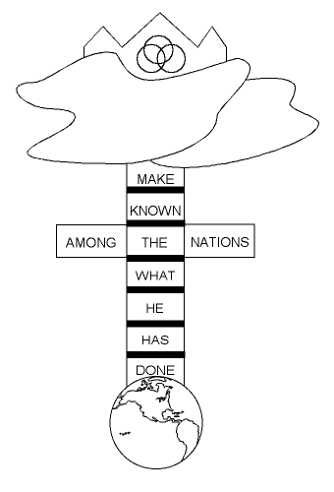Now you can grow in Christ

2 Peter 3:18

Dear Jesus, I love You. Thank You for dying on the cross for my sins. Thank You for rising from the dead on Easter morning to give me the power to live a good life.
Forgive me for the wrong things that I have done, said or thought. I want to ask You to come into my life. Help me to obey Your teachings and be the loving person You want me to be. Amen.

The Good News Bracelet

Yellow

God loves you! He is the light of the world

John 3:16
John 8:12

Sample Prayer:
Blue

Your sin makes you sad. It mades God sad, tool

Romans 3:23
Red

Christ shed His blood & died for us to save us from sin.

Romans 5:8
Clear

When you receive Jesus, your sins are forgiven

John 1:12
Green

Now you can grow in Christ

2 Peter 3:18

Dear Jesus, I love You. Thank You for dying on the cross for my sins. Thank You for rising from the dead on Easter morning to give me the power to live a good life.
Forgive me for the wrong things that I have done, said or thought. I want to ask You to come into my life. Help me to obey Your teachings and be the loving person You want me to be. Amen.

www.christiancrafters.com

Page 52 of 63 Revised: 2/15/2008

Page 13 of 63 Revised: 02/09/2009

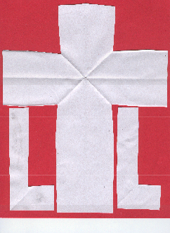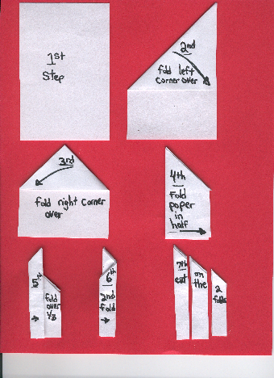Welcome Activities continued:

Jesus Arise!
by Christine Cahill
2 PAGES OF CONTENT This is good to do, if you are using the Folded Paper gospel presentation about Jesus and the two criminals.

Make a copy of the drawings for each child. (Click here to get the clip art drawings: Empty Tomb, AND Risen Jesus. You will need to hit your back browser to return.)

Cut the Empty Tomb to fit around a small Styrofoam cup, let the children color it. Glue it around the cup.

Cut out the Risen Jesus

Cut a small slit in the bottom of the cup, small enough to fit a popsicle stick through. Put the stick up through the cut. Glue Jesus to the top of the stick. Glue a small piece of cotton at the bottom of his feet.

As the stick goes up and down, Jesus arises from the tomb! Copyright 2000 Christine Cahill (The drawings that Christine used for her craft idea are copyright free.)
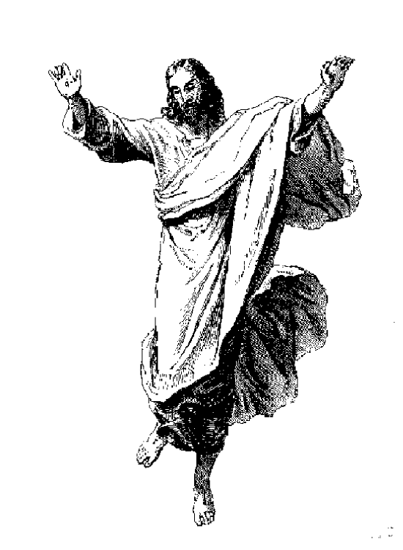Page one of Jesus Arise
Page 14 of 63

Revised: 02/09/2009

Page 51 of 63 Revised: 2/15/2008

Appendix continued:
Reference Guide to use whenever you may be sharing your faith with a child:

CLARIFYING QUESTIONS

These are some good questions to ask after presenting the gospel to see if the child truly understands what it means to accept Jesus as his/her Savior.
To determine why the child responded to the invitation, after the Gospel message has been given and before he/she prays, you can ask:
- What do you want to talk to me about?
Before a child prays to accept Jesus as his/her Savior, be sure the child understands their need of Jesus?
- Why do you need Jesus?
- What keeps you from going to heaven?
- What is sin?
- Have you ever sinned or done anything wrong?
Be sure the child understands the way of salvation?
- What did Jesus do for you?
- Why is Jesus the only one who could pay for your sin?
If the child understands – lead in a simple prayer to express his or her faith.
- Would you like to pray now and tell God what you believe?
For assurance after salvation:
- What has Jesus done for you?
- How do you know?
- How do you know you have eternal life?

Ask clarifying questions when you visit the child to see if the child understood what it meant when he or she had prayed. Asking clarifying questions is a good way to begin the discipleship process.
For assurance after salvation:
- What has Jesus done for you?
- How do you know?
- How do you know you have eternal life?
If the child is confused and cannot answer these questions, go over the gospel tract with them again. Then review the questions at the top of the page and see if the child is ready to trust Jesus as his or her Savior.

Welcome Activities continued:
Page 2 of Jesus Arise; this tomb gets wrapped around a Styrofoam cup.

Page 50 of 63 Revised: 2/15/2008

Page 15 of 63 Revised: 02/09/2009

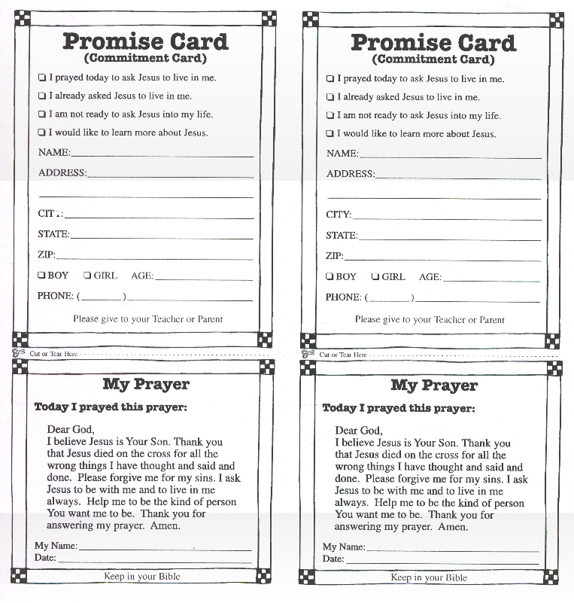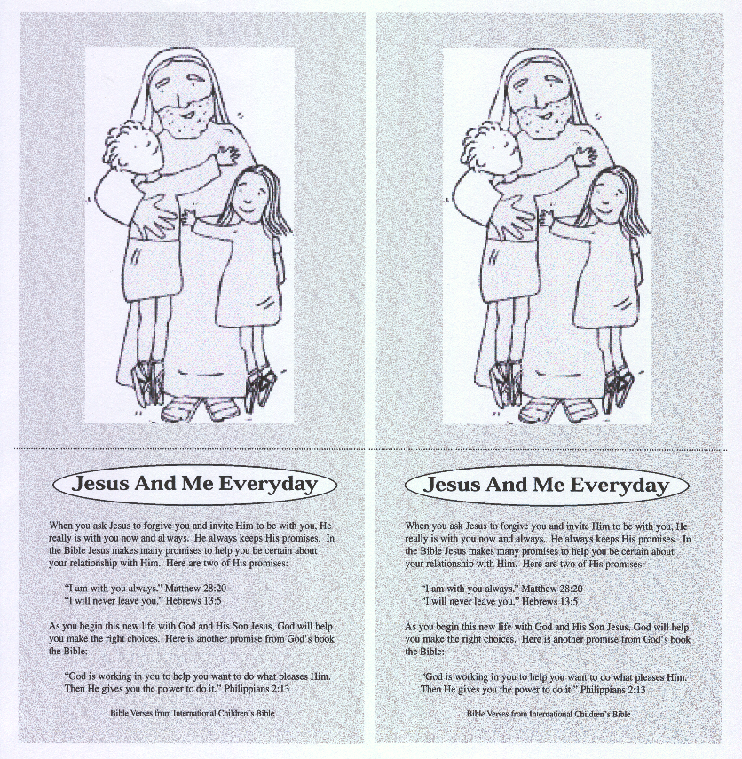Welcome Activities continued:

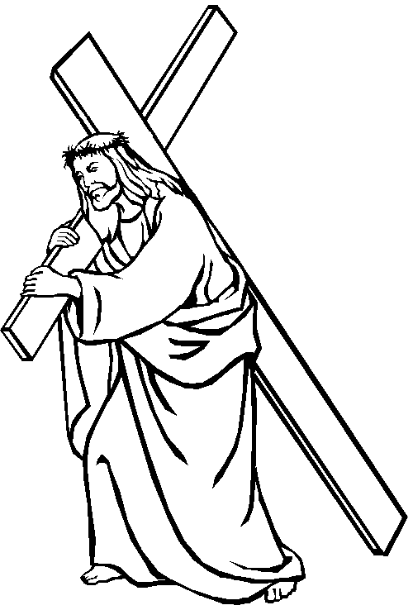

"If anyone would come after me, he must deny himself and take up his cross and follow me."
Mark 8:34b (Sermons4Kids.com)

Page 16 of 63 Revised: 02/09/2009
Page 49 of 63 Revised: 2/15/2008

Appendix
Welcome Activities continued:

Take Up Your Cross and Follow Jesus
Mark 8:31-38

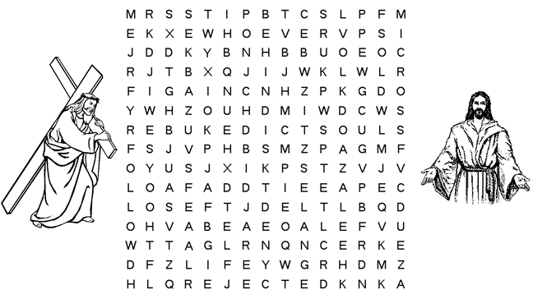

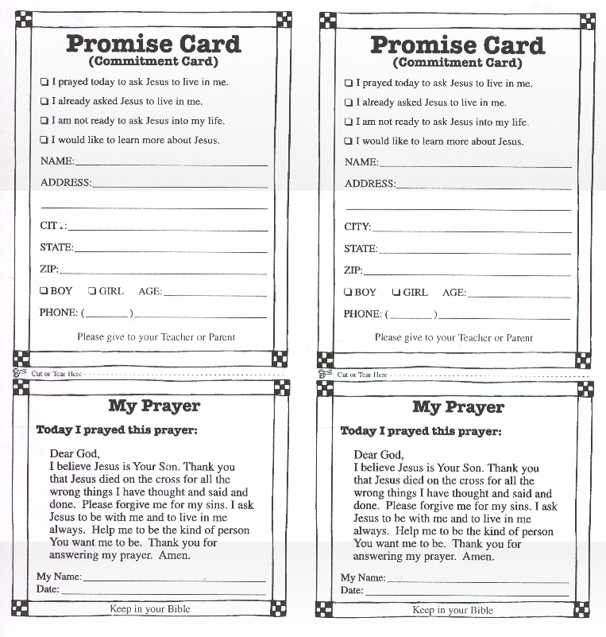teach suffer rejected killed Peter
rebuked behind Satan crowd disciples
deny himself cross follow whoever
save life lose gain soul

Bible Verse

"If anyone would come after me, he must deny himself and take up his cross and follow me."
Mark 8:34b

Puzzle created with Vocabulary Worsheet Factory Sermons4Kids.com

Page 48 of 63 Revised: 2/15/2008
Page 17 of 63 Revised: 02/09/2009

Welcome Activities continued:

Take Up Your Cross and Follow Jesus!
Mark 8:31-38

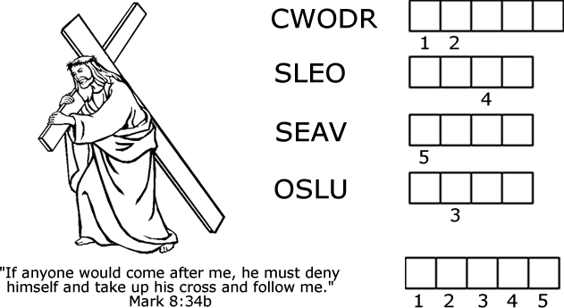

www.sermons4kids.com

crowd, lose, save, soul

APPENDIX
“Promise” commitment cards with prayer from “Following Jesus” curriculum “Jesus And Me Everyday” cards from “Following Jesus” curriculum Clarifying Questions about a Child’s Understanding of the Gospel from CEF Visual of the “Folded Paper” Gospel Message
English Beaded Bracelet tract Spanish Beaded Bracelet tract Beaded Bracelet charts Checklist for materials
Easter Outreach Event Worksheet Community Survey and Bible verses

Page 18 of 63 Revised: 02/09/2009

Page 47 of 63 Revised: 2/15/2008

FOLLOW-UP MATERIALS
Look in the Follow-up Coordinators Job Responsibility for how to follow-up the children. Follow-up material for the children who want more information:
- Child Evangelism Mailbox Club correspondence course. Web site: www.mailboxclub.com (can register a child on-line) Mailbox Club locally: 305 Oak Fair Way, Bakersfield, CA 93309 Mailbox Club: P.O. Box 190, Warrenton, MO 63383-0190
You will need to know the child’s name, age, and mailing address, so the child gets the age appropriate lessons.
CEF in Bakersfield: (661) 873-9032 (can get Mailbox cards to mail in)

Order Bibles for free with Bibles For Children Inc.
The purpose of “Bibles for Children Inc.” is to place free Bibles in the hands and homes of unchurched children who do not have Bibles, but want a copy of God’s Word. You are to ask
“If the child has a Bible?” If the answer is “NO”, then ask “If the child would like a Bible?”
If the answer is “YES”, then a free Bible(s) will be sent upon request.

To order the Bibles: Write to:
Bibles for Children Inc. or Call: (607) 334-1926
771 County Road 4
Oxford, NY 13830

Free “follow-up” materials www.jesusforchildren.org ,
click on “Products”, “Following Jesus” Evangelism and Discipleship Course for Children free online, “The Complete Teacher/Mentor” guide

Have a Jesus video party (if did not already use it) as another reason to get together.
Teenagers:
Contact Youth For Christ
(661) 323-9041

www.yfckern.org
2131 California Av.
Bakersfield, CA 93302
Welcome Activities continued:

Take up your cross and follow Jesus!

Can you find the path to Jesus?

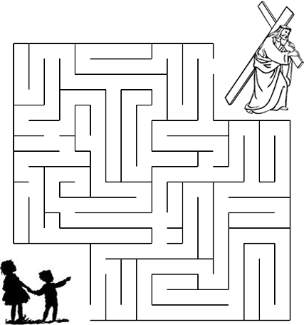
"If anyone would come after me, he must deny
himself
and take up his cross and follow me." Mark 8:34b
Puzzle created with Discovery School Puzzlemaker

Sermons4Kids.com

Page 46 of 63 Revised: 2/15/2008

Page 19 of 63 Revised: 02/09/2009

Welcome Activities continued:

CRAFT IDEA - EGG MOSAICS
Preparation:
- Create a Sample in Advance!

- In advance create cardboard egg shapes for each child. Prepare multiple colored 2” square tissue pieces. Placing a handful in a baggie works really well!

- Prepare dishes of ½ water and ½ school glue mixtures. Having water color paint brushes really helps with this craft.
Have the children write their names on one side of their egg! Have them decorate their cardboard eggs by painting the cardboard with the glue mixture and placing the different colored tissue paper in an over-lapping fashion.

This should dry quickly enough for the children to take home! Very Pretty!

SNACK IDEA – Bird Nest Cupcakes
Can totally prepare this a head of time or partially prepare and use as a craft to decorate.

Bake and frost cupcakes. Top with a circle of toasted coconut. Place a cluster of jellybeans in the center for eggs. To toast the Coconut: Spread coconut flakes in a thin layer on a baking sheet and toast in 350-degree oven for 7-9 minutes until golden brown.

Watch closely, as coconut can burn quickly.

Can prepare cupcakes a head of time and let the children decorate their cupcakes with the jelly beans and toasted coconut (if they like coconut).

Method of Sharing the Gospel that everyone is to finish with:
CHILD EVANGELISM TRACT
  - Printed Child Evangelism Fellowship Tracts can be placed on the outside of the bag as a label or placed inside as a card. (the Child Evangelism name should appear somewhere on the card)
  - After the gospel message is given in a large group setting, have the children get into small groups or with one adult to one child.
  - Complete the evangelistic craft (if you use one) and ask clarifying questions.
  - Read the gospel tract, that is on the outside of the Easter bag, to each child – either one adult to one child or in a small group setting (one adult to two - five children).
  - Ask the child(ren) if they are ready to Admit that they have sinned, tell God that they are sorry that they have done things that make Him sad, Believe that Jesus is God and made it possible for his/her sins to be forgiven, and would like to Call on Jesus, by praying, to become a member of His family.
  - Give the child, who is ready to accept Jesus as his/her Savior, an opportunity to pray to trust Jesus as their Savior.
  - Have each child fill out the “Promise” commitment card. Tear off the top half and turn it in (for a drawing and also for visitation and follow-up by a church member).
  - Let the child keep the bottom half of the commitment card (Promise Card).
  - Give the child, who prayed, a “Jesus and Me Everyday” card.

Child Evangelism Fellowship Tract

Page 20 of 63 Revised: 02/09/2009

008

Page 45 of 63 Revised: 2/15/2
GOOD NEWS
GOD WANTS YOU IN HIS FAMILY
God loves you. | Admit you are a sinner. | Believe Jesus died for your sin. | Choose to believe on Jesus.
God made the whole world. He made you and loves you.  “I have loved you with an everlasting love.” (Jeremiah 31:3) | You were born a sinner and have done sinful things. Sin keeps you apart from God.  “All have sinned and come short of the glory of God.” (Romans 3:23) | Jesus Christ, God’s perfect Son, died to pay for our sins and came alive again. He is living today.  “Christ died for our sins… and He rose again the third day according to the Scriptures.”  (1 Corinthians 15:3,4) | - Admit that you sin.  - Believe Who Jesus is and What He has done for you.  - Call on Him in prayer and receive Him by faith in His promises:  “As many as received Him, to them He gave the right to become the children of GOD.” (John 1:12)  “Jesus -  I believe You are God. Thank you for loving me and for dying for all my sins. I believe you came alive to give me forgive- ness and life with You forever. Come into me right now. Help me to live the way You want. Thank You. Amen”

Method of sharing the Gospel:
JESUS VIDEO FOR CHILDREN
Supplies: video, TV, VHS, extension cord, Easter bags, commitment cards, pencils, prize for drawing

The goal is to give the children a chance to pray and trust Jesus as their Savior. God may have prepared some of their hearts to make that decision at your outreach.

Show the video. (Perhaps just show the second half of the movie, either before or after the Zaccheus episode. It is a long movie.)

At the end of the movie:

Personal invitation to accept Jesus:
  - Break into small groups or one adult per child

Ask Review Questionnaire:
  - Where was Jesus born? (in a stable)
  - How was Jesus able to heal all those sick people? (because He was God)
  - Why did Jesus have to come down from Heaven to earth? (because we sin)
  - Why did Jesus die on the cross? (to be punished for our sins)
  - How many people sin?
(all)
  - How do we invite Jesus into our lives?
(by praying: talking with God about what we believe)

  - Ask the children if they would like to be a part of God’s family, to have their sins forgiven and go to heaven?
  - Adults have the Easter bags for the children.
  - Read the Child Evangelism Tract label with the child(ren) that is on the outside of the Easter bags or the prayer on the “Promise” commitment card.
  - Give each child, who is ready, a chance to say the prayer and accept Jesus as their Savior.
  - Have each of the children fill out the “Promise” commitment cards or you fill it out for them.
  - Tear off the top part of the “Promise” commitment card and give the bottom half to the child; put the top half in the bucket for a drawing. After the drawing these cards go to the follow-up coordinator to be able to follow-up with the child at another time.
  - Give out the “Jesus and Me Everyday” card to the children who prayed.
  - Have a drawing for a prize with the top half of the “Promise” commitment card.

Welcome Activities continued:

MIXER GAME

Need: copy for each child. Need a pencil for each child. Children are to mingle.
Goal: to see who can get another child’s name in each block before time is called. Try to get a different child’s name in each block.
Who has a dog? | Who has an older sister? | Who has seen a movie about  Jesus?
Who has a pet rabbit? | Who can stand on their  head? | Who can speak another  language?
Who has a cat? | Who plays soccer? | Who has a Grandmother who lives with them?
Who is the youngest person  here? | Who can do two cartwheels  in a row? | Who went to church last  week?

Page 44 of 63 Revised: 2/15/2008
Page 21 of 63 Revised: 02/09/2009

Relay Races:
- Plastic egg roll race.
GAMES

Method of sharing the Gospel:

  - Need: 2 plastic eggs, (or real eggs), 4 newspapers rolled up length wise and taped, and masking tape for the lines
  - Create two teams. Divide each team in half and have each half stand at opposite ends of a room or playing field. Place four short pieces of masking tape on the ground to mark where each start line is, for the students to line up behind.
  - There can be two long pieces of masking tape, to make a straight line, joining the starting lines for each team.
  - The person in front of each team is given a taped, rolled up newspaper. This is used to push an egg down the long masking tape line, from one starting line to the other half of your team’s starting line. The child is to keep the egg on the masking tape as much as possible. The team member on the other end will return the egg to the first side. Etc… First team to finish wins.

What is sin?
- Have you ever done or said anything that is wrong? That would make God sad?
Draw a horizontal line inside the heart to make a cross. Ask:
- What did Jesus do for you? (paid the penalty for my sins. He, who knew no sin, became sin on our behalf, so that we could take on His righteousness.
2 Cor. 5:21)

Why is Jesus the only one who could pay for your sins?
He is God. He was perfect. He had no sins that needed to be punished. So He was able to be our substitute to pay for our sins.
Turn the rectangular paper over; on top half draw the third circle, with a heart and the letters “ABC” inside the heart. Ask:

XXXXX YYYYY
X→egg_ Y→egg
XXXXX YYYYY

Being a part of God’s family is as simple as saying what three letters? (ABC)
On the bottom half of second side, draw the fourth circle, with a heart and the words Admit,

- Egg carried in a spoon race. (jelly beans or cotton balls can also be used in place of eggs)
  - Need: 2 plastic or hard boiled eggs and 2 spoons: One egg and one spoon for each team. (Have extras incase of breakage.)
  - Create two teams. Divide each team in half and have each half stand at opposite ends of a room or playing field. Give the first child in each starting line a spoon and a hard-boiled or plastic egg. Start the relay. The child at the front of his/her line is to cross over to his/her team on the opposite side, carrying an egg in a spoon. That person in the opposite line then takes the spoon with the egg and carries it back to the first line. Team to finish first with everyone carrying the egg wins.

A Tricky Spoonful
  - Same directions as the above race, egg carried in a spoon, with an addition:
  - As the children are passing to the opposite side the game coordinator is to shout out, “spin” or “walk like a duck”. The children then have to perform this action while crossing to the other side. Switch actions as much as you like during the play.
  - You can make up more actions steps to shout out, especially if there are older children playing this game.
- Burlap sack bag race. (or use old pillow cases) Need:
2 burlap bags (have an extra bag incase one rips); 4 markers for starting lines. Create two teams. Divide each team in half and have each half stand at opposite ends of a room or playing field. Child puts both feet in a burlap bag, hops down to opposite line. Child gives the burlap bag to person in front of that line. He/she hops back to first line. Winning team: everyone on a team finishes the race before the other team completes the race.
Believe, Call in the circle. Ask:
- What does A stand for? Admit that you have sinned
- What does B stand for? Believe Jesus is God & paid the penalty for all of your sins.
- What does C stand for? Call on God in prayer in order to have your sins wiped clean
or forgiven and in order to become adopted into God’s forever family.
(Emphasize Rev. 3:20, John 1:12, & Heb. 13:5 Revelation 3:20: “Look! I stand at the door and knock. If you hear my voice and open the door, I will come in, and we will share a meal together as friends. John 1:12: “But to all who believed Him and accepted Him, He gave the right to become children of God.” Heb. 13:5b: “…For God has said, “I will never fail you. I will never abandon you.”[ Holy Bible. New Living Translation copyright © 1996, 2004 by
Tyndale Charitable Trust. Used by permission of Tyndale House Publishers.

Pray: If a child is willing and ready – lead them in prayer. “Dear Jesus, I believe You are God. Thank you for loving me and for dying for all my sins. I believe you came alive to give me forgiveness and life with You forever. Come into me right now. Help me to live the way You want. Thank you. Amen.

Page 22 of 63 Revised: 02/09/2009
Page 43 of 63 Revised: 2/15/2008

Methods of Sharing the Gospel continued:

We celebrate Easter because it was the day that Jesus came back to life, after being punished for our sins. Because of Easter I can choose to accept Jesus’ love for me and forgiveness of my sins. I can be in God’s family.”

Four Circles Gospel Presentation Personal invitation to accept Jesus:
  - Break into small groups or one adult per child. * Questions on following page to ask.
  - Craft time: Give each child a rectangular piece of paper. Give instructions to fold the paper in half. Instruct the children to draw the four circles and have the children explain in a few words what each circle means.
  - Ask the children if they would like to be a part of God’s family, to have their sins forgiven and go to heaven?
  - Adults have the Easter bags for the children.
  - Read the Child Evangelism Tract label with the child(ren) that is on the outside of the Easter bags or the prayer on the “Promise” commitment card.
  - Give each child, who is ready, a chance to say the prayer and accept Jesus as their Savior.
  - Have each of the children fill out the “Promise” commitment cards or you fill it out for them.
  - Tear off the top part of the “Promise” commitment card and give the bottom half to the child; put the top half in the bucket for a drawing. After the drawing these cards go to the follow-up coordinator to be able to follow-up with the child at another time.
  - Give out the “Jesus and Me Everyday” card to the children who prayed.
  - Have a drawing for a prize with the top half of the “Promise” commitment card.
  - If you have not done so yet, give each child their Easter bag.

Get the children into Small Groups: (need a rectangular paper & a pencil per child)
The small group leader will:
- give each child a rectangular paper. Have them fold the paper in half.
- one section at a time - give instructions what the children are to draw on each of the 4 sections.
- ask the children clarifying questions that go with each section as they draw
- give the children a chance to pray to receive Christ’s gift of salvation
- have the children practice sharing with each other what the circles mean
- homework: have the children share the circles with someone at home or a friend

Clarifying Questions:
Fold a rectangular paper in half. On the top half section draw the first circle and ask:

1. What are some reasons that we know that God loves us?
(God is always around to help us, gave us creation, He gave us His Son, Jesus, so we could become His children)

On the bottom half of paper, draw the second circle with a heart and a line going down the center of the heart? Ask:

2. Why do you need Jesus? Or What separates you from God’s love? (sin)
Page 42 of 63 Revised: 2/15/2008

Games continued:

- Race stepping on egg-shaped cardboard.
  - Need: 4 egg shaped pieces of cardboard, larger than a child’s foot, so the children can step on them.
  - Two egg shaped pieces of cardboard per team. Need 2 markers so the teams know how far to race, before returning to their starting line.
  - Two teams. Children are to line up behind the first person on their team. Children work in pairs. The first two children on a team start out. One child starts out by only walking on the cardboard egg shape. The second child’s job is to rotate the egg shapes, moving them forward, so that the first child has something to walk on. When those two get to a marker at the opposite side, they exchange positions and hurry back to their original line. Then the next two children in line start off.
  - Winning team: the first team to have everyone complete the race.

Tri-hop-athon
  - Need: 3 markers; two teams
  - Choose three landmarks or markers to race to in the building or outside.
  - Have teams line up, standing in a row behind the first person at their start line.
  - Start the contest. The first players must hop on one foot to the second marker, skip from there to the third marker, and then jump all the way back on two feet to tag the next teammate in line at the first marker. The first team whose members have all completed the course wins.

Duck Walk Race
  - Need: 2 markers for a finish line; two teams
  - Have teams line up, standing in a row behind the first person at their start line. To begin, the first children in line must squat down and grasp their ankles with each hand. On the word “go” they waddle to a designated finish line. They can’t let go of their ankles or they are disqualified. When they cross the finish line and stand up, then the next person at the starting line can start waddling to the finish line. First team with everyone over the finish line wins.

Three-Legged Race
  - Need: bandanna for each team; two teams, whistle or the game coordinator to say “Go” No field day is complete without this classic race. But don't let the simple rules fool you; sharing a leg is no mean feat. HOW TO PLAY: 1. Divide players into teams of two (matching an adult with a child keeps things fair and interesting). Using a bandanna, each pair ties one partner's right ankle to the other's left ankle. 2. When the whistle blows, all of the pairs, assembled side by side at the starting line, race to the finish line. The first team to cross the finish line wins.

Page 23 of 63 Revised: 02/09/2009

Games continued:
- Across The Great Divide Game (different than the skit mentioned later in the manual)
  - Need: markers to indicate start and ending line.
  - The leader will divide the group into teams of six or less. Team members must stand side by side and touch their feet together so they are connected. Group members on each end will only have one foot connected. The entire group must get across a certain area without breaking contact with their feet. If the participant’s feet come apart, they must start over. Do not allow participants to tie shoelaces together, the laces may break and become a hazard.

Rock, Paper, Scissors Tag
  - Need: markers or masking tape for a center line and end lines
  - Remember facing down a pal and chanting "Rock, paper, scissors, shoot!"? For example: You'd throw out your closed fist (rock), while your friend countered with two splayed fingers (scissors). "Rock breaks scissors!" you'd taunt. "I win!" Here, we've simply taken this old favorite and added running. The result, well, rocks.

HOW TO PLAY:
    - Make 1 centerline and 2 back lines at the ends of a yard or field (leave space past these back lines so those running full tilt have room to stop).
    - Make 2 teams. Each team then huddles at opposite ends of the field and chooses which hand signal to throw. (In case you've forgotten: rock breaks scissors, scissors cuts paper, paper covers rock.)
    - Have the teams gather at the centerline, fanning out nose-to-nose.
    - Together (and with gusto), all chant: "Rock, paper, scissors, shoot!" On "shoot," players quickly throw their pre-chosen selection.
    - The team that loses the shoot must race for the safety of its own back line, trying to avoid being tagged by the winning team.
    - Any player who gets tagged must defect to the other side. If both teams throw the same shoot, all must quickly sit down. The last one to hit the ground switches teams.

Elbow Tag
  - Need: large area to play
  - The quirky rules for this fast-moving version of tag allow players to participate or "grab an elbow" to catch their breath.

HOW TO PLAY:
    - Divide the group into pairs. Have partner’s link elbows and stand in a very large circle, leaving at least 10 feet between each pair, or the pairs can be staggered throughout the field. Now designate one player as "It"--call him Greg--and choose another player, Ann, as the one being pursued. If Greg can tag Ann, she becomes "It." However, if Ann wants to escape (and take a rest from running), she simply runs toward one of the standing couples and links elbows with one of the pair to make a threesome.
    - In this game, two is company but three is a crowd: When Ann latches on, the one member of the pair whose arm she did not take must break away at top speed. This player instantly becomes new prey for "It"--until he dashes to yet another pair for safety. The confusing transitions can provide a break for weary runners and give even a slow-moving "It" a chance to catch Ann.

Other ideas: musical chairs, egg toss or water balloon toss, tug-a-war, pass water in a cup relay

Methods of Sharing the Gospel continued:

Start by asking the question: “Why do we celebrate Easter?”
Then say, “I’m going to tell you a story about why Easter is important, using 4 circles.”

FOUR CIRCLES GOSPEL PRESENTATION
Circles
      - Circle by itself – no beginning no end. Characteristics of God. He has no beginning or end. God has always been around. Nobody made God. God made everything. Heavens, earth, birds, animals, flowers. He is so great – no one can do what God does.

Circle with heart and cross –
Heart - God loves you. He made all these good things for us (birds, plants, animals…) GOD GAVE US HIS CREATION Cross – God hates sin. Things we have done wrong separate us from God. Sin breaks God’s heart, (draw the vertical line first from point to
•

•
point in the heart shape.) God is just and righteous, as well as full of love. He knew we had sinned, disobeyed, and needed to be punished. He sent
His Son to take our punishment. Jesus died on the cross paying for our sins. (Complete making the cross by adding the horizontal line.)

GOD GAVE US HIS SON
        - Jesus came alive again wiping away our sins.

      - Circle, heart and ABC – how to live in God’s forever family is as simple as saying ABC (Have children say ABC.)

      - Circle with A Admit. B Believe C Call, tomb, cross and arrow upward
A – Admit that you have done things that are wrong and need to be punished for those sins. Do you want to be punished for your sins and be separated from God forever or do you want to trust Jesus, who died in your place and was punished for your sins. He can forgive you. (Admit sin & now want to obey God.)
B – Believe that God loves you, that Jesus is God, and that He made it possible for your sins to be forgiven. (can review picture in heart)
C – Call on Jesus in prayer. John 1:12, Rev. 3:20 You must be willing and ready to believe Jesus is God and to trust Him to forgive your sins. Be willing to admit you have sinned and that sin makes God very sad. He hates sin. (Sin makes the child sorrowful when he/she realizes that Jesus had to die for his/her sins.)

Pray: Child is willing and ready – lead them in prayer. Emphasize Heb. 13:5

Page 24 of 63 Revised: 02/09/2009
Page 41 of 63 Revised: 2/15/2008

Methods of Sharing the Gospel continued Folded paper
Second story about Three Friends, Ticket to Heaven

Personal invitation to accept Jesus continued:
  - Read the Child Evangelism Tract label with the child(ren) that is on the outside of the Easter bags or the prayer on the Promise/Commitment card.
  - Give each child, who is ready, a chance to say the prayer and accept Jesus as their Savior.
  - Have each of the children fill out the “Promise” commitment cards or you fill it out for them.
  - Tear off the top part of the commitment card and give the bottom half to the child; put the top half in the bucket for a drawing. After the drawing these cards go to the follow-up coordinator to be able to follow-up with the child at another time.
  - Give out the “Jesus and Me Everyday” card to the children who prayed.
  - Have a drawing for a prize with the top half of the “Promise” commitment card.
  - If you have not done so yet, give each child their Easter bag.

Games continued:

- Memory Verse Practice
  - Needed: a large white board, white board marker and eraser
  - The children sitting quietly near a white board. Have the memory verse (John 3:16) printed out in large letters on a white board. Erase one or two words at a time and review the verse. Keep erasing words and reviewing until you feel like the children can say the whole verse. Then ask if there are any brave souls that want to stand up and say the whole verse by themselves.

John 3:16
16“For God so loved the world that he gave his one and only Son, that whoever believes in him shall not perish but have eternal life.

Memory Verse game, relay race
  - Need: two sets of index cards, different color for each set. 2 tables, starting point markers
  - Two teams; each team lined up behind the first person at the starting point.
  - At two different areas, either on two tables or on the floor, have a set of index cards (stacked, but scrambled so they are not in order). Each card will have a phrase or word on it that corresponds to the memory verse. All the cards are turned upside down. The person in the front of each line runs down, turns one card over and tries to put it in the place where it belongs in the sentence. Then they run back to the back of their line. The new person in the front of the line then runs to the cards and repeats the pattern. The team to finish first and have the cards in the correct order wins.

Words to print for the memory relay race are on the following page: You need Avery Label’s # 5160 (white address labels). Then place labels on index cards. Preferably each team shall have a different color of index cards.

- Play “Hang Man” game with memory verse (if you want a different drawing, make a drawing of a basket and fill it with Easter eggs; each egg has the wrong letter or word that was guessed written on it) Two teams lined up. The first two members from each team come to the front and take turns trying to say the correct word in the beginning of the verse. They return and the next two people in line go to the front and guess the next word in the verse. The game continues until the verse is written correctly on the white board.

Page 40 of 63 Revised: 2/15/2008
Page 25 of 63 Revised: 02/09/2009

JOHN 3:16 FOR GOD SO LOVED

THE WORLD THAT HE GAVE HIS

ONE AND ONLY SON, THAT WHOEVER

BELIEVES IN HIM SHALL NOT PERISH,

BUT HAVE | ETERNAL | LIFE
JOHN 3:16 | FOR GOD | SO LOVED

THE WORLD THAT HE GAVE HIS

ONE AND ONLY SON, THAT WHOEVER

BELIEVES IN HIM SHALL NOT PERISH,

BUT HAVE ETERNAL LIFE

Methods of Sharing the Gospel continued:
Second story using folded paper is about Three Friends, Ticket to Heaven
- Three close friends did everything together: tagged buildings, stole, got in trouble at school together.
- One of the friends was invited to go to church. He went, but the other two boys did not want to go.
- At church the boy heard that God created him. God loved him. (Jn.3:16) God had a wonderful plan for his life. (Eph 2:10). So far his life had not been that great. No one loved him, not even his mom. After hearing about God’s love, he started feeling different. He knew that he needed God’s love. He began to feel sorry for what he had done. He thought God would not accept him because of all of the things he had done, so he told God that he was sorry. He received Jesus forgiveness of his sins and God’s love. John 1:12. Then he was given a ticket to heaven.
- He folded the ticket and put it in his pocket.
- He saw his two friends and told them what he had heard. They wanted a piece of his ticket so he folded it over evenly (2 times to make 3 sections) and then tore it so that each friend would have a piece of the ticket.
- The first boy started reading the Bible and tried to live a life that pleased God.
- The two other boys joined a gang and continued to do wrong things. One day they got in an accident and died.
- The two boys stood before God and gave Him their tickets. God unfolded the tickets. He said, “You had a chance for God’s love, like your friend, but you both CHOOSE differently (wrong choice). You are destined for HELL, not heaven.
- The first boy lived a long life. He had lived a life trying to please God. When he died God asked him why he should be let into heaven. The man told God of all the things he had done for God. God said, “Well do you have anything else. The man felt the remaining part of the ticket in his pocket, but told God that part of it was gone. God opened the ticket. It was a CROSS. God said, “You can come into heaven.”

Why do you think the one boy was given a new life with God and allowed into heaven, while the other two did not get to go to heaven? Would you like to know how you could have a new life with Jesus?

Personal invitation to accept Jesus:
  - Break into small groups or one adult per child
  - Craft time: Give each child a piece of paper. Give instructions on how to fold the paper. Instruct the children where to tear the papers.
  - Assemble the papers to look like the cross.
  - Assemble the papers to spell Hell. Ask why the two boys did not get to stay in Heaven, but instead went to Hell?
  - Assemble the papers to spell Life. Ask why the one boy was allowed to stay in Heaven?
  - Ask the children if they would like to have the Life that Jesus offers, so that they can have their sins forgiven and go to heaven?
  - Adults give out the Easter bags to the children.

Page 39 of 63 Revised: 2/15/2008

Methods of Sharing the Gospel continued:
Folded paper - Jesus and the 2 Criminals
  - The criminal that turned away from God went to HELL. (Spell out Hell with the pieces of paper. Lightly tape the pieces of paper to a large piece of construction paper to make it easier to see.)
  - This criminal who turned to Jesus had LIFE, meaning he became a part of God’s life, His family. (rearrange the pieces of paper to spell out LIFE )

Why do you think the one criminal was given a new life with God and the other one didn’t get it? Would you like to know how you could have a new life with Jesus?

Personal invitation to accept Jesus:
  - Break into small groups or one adult per child
  - Craft time: Give each child a piece of paper. Give instructions on how to fold the paper. Instruct the children where to tear the papers.
  - Assemble the papers to look like the cross with the two criminals.
  - Look at the cross: ask, “Why did Jesus have to die on the cross?” “What is sin?”
  - Reassemble the papers to spell Hell. Ask “Why the one criminal went to Hell?”
  - Reassemble the papers to spell Life. Ask “Why the other criminal went to heaven?”
  - Ask the children if they would like to have the Life that Jesus offers, so that they can have their sins forgiven and go to heaven?
  - Adults have the Easter bags for the children.
  - Read the Child Evangelism Tract label with the child(ren) that is on the outside of the Easter bags or the prayer from the Promise/commitment card. Ideally: one adult/child, or one adult/2-5 children.
  - Give each child, who is ready, a chance to say the prayer and accept Jesus as their Savior.
  - Have each of the children fill out the “Promise” commitment cards or you fill it out for them.
  - Tear off the top part of the “Promise” commitment card and give the bottom half to the child; put the top half in the bucket for a drawing. After the drawing these cards go to the follow-up coordinator to be able to follow-up with the child at another time.
  - Give out the “Jesus and Me Everyday” card to the children who prayed.
  - Have a drawing for a prize with the top half of the “Promise” commitment card.
  - If you have not done so yet, give each child their Easter bag.

SKITS

Purpose of Skits: to transition from the games to the gospel message; helps to get the children’s focus on a quieter activity

Trying To Bridge The Gulf
(main point: We can not be good enough to get to heaven on our own; we ask/trust Jesus to get us there.)
  - Have a large section marked off with masking tape at both ends – to make a gulf.
  - Need five actors.
  - Need something to use for a bridge, such as a roll of paper towels.
  - Jesus is on one side of the gulf.
  - Actors take turns trying to get over the gulf, starting at the opposite side that Jesus is at. The goal is to try and reach Jesus. One is on an imaginary motorcycle, one is on a horse, one tries running and jumping. All fail and fall into the gulf.
  - The last person walks up to the gulf. He studies the distance between himself and Jesus. This actor holds out his hand to Jesus.
  - Jesus says, “Well done.” And then Jesus lays a bridge for the child to cross.

Clarifying Questions for Trying To Bridge The Gulf
- Were any of the students good enough to get to Jesus and heaven on there own?
- What is the only way they could get to heaven?
- None of us are good enough to get to heaven on our own. We all need to make that choice of trusting in Jesus as our Savior so that we can be in heaven with Him someday.

Trying To Mold Jesus Into What You Want
(main point: In order to have a relationship with Jesus, we have to do it His way, accept what Jesus did on the cross for us. He is available and loves us, but He will not become like us in our actions.)
  - Jesus stands in one position with His arms stretched out, like He is on a cross.
  - People (one by one) come up to Jesus and try to reshape Jesus into their image of what is cool. One actor is acting like he is smoking and tries to get Jesus to smoke.
  - Another actor is counting his money, fans it in front of Jesus and tries to get Jesus to take some of his money. The third actor acts real proud, boastful, showing off his muscles, trying to get Jesus to come and lift weights with him. (You can come up with your own actions that you think would relate to the children.)
  - The first actor puts down his cigarette, looks at Jesus, and then stands beside Jesus as if he is on a cross too. Then all of the students follow what the first actor did.

Clarifying Questions for Trying To Mold Jesus Into What You Want
- People try to make Jesus into what they want, “I can do it my way.”
- Whose way do we need to obey, if we want to be in God’s forever family?
Jesus says, “I am the way, the truth and the life. No one comes to the Father except through Me.” John 14:6 The only way to be in God’s family is through Jesus. Then we can get to heaven.

Page 38 of 63 Revised: 2/15/2008
Page 27 of 63 Revised: 2/15/2008

Skits continued:
Crossing The Great Divide Skit experientially presenting The Gospel

If you have a large group of children, ask for 2 or 3 volunteers to come up and be the participants. If you have a small group of children and have the time, then let each child take a turn in trying to cross the great divide.

Materials: newspaper cut into various sizes ranging from a whole page to small scraps that are too small for a child’s foot to totally fit on, enough to cover the area you will use for the activity below; a treasure box containing enough white stones (Revelation 2:17b) for each child; a roll of paper towels.
- If possible, prepare the activity area ahead of time. Lay out papers on the floor. Place them so it would be impossible for the kids to get from where they are to where Jesus is without touching the floor. The side on which the kids begin should have large pieces of paper close together, making it easy for them to move across. But as they get closer to your side, the pieces get smaller and further apart. It should APPEAR to be possible, but it must BE IMPOSSIBLE to accomplish. Have the children all line up on one side of the room against the wall. One child should try to come across at a time.
- Tell the children they are to try and get from where they are to where you are without touching the floor at all. Make sure it’s impossible. If someone makes it across, the activity will lose its significance. One Rule: they are not to walk on or touch the floor at all. They can only step on the paper.
  - Hold the treasure box in your hands – it represents what they are trying to reach. Call out encouraging words to each child as s/he attempts to cross over to you.  If they touch the floor at all, they are dead. They must fall where they are.
  - Have them come across one at a time. They can try to learn from one another, but the “dead bodies” will add to the difficulty. They can’t touch the “bodies” either.
  - When everyone has had a chance, lay down a strip of paper towels from your side to each individual child.
  - Approach one child at a time and say, “I do not want you to be dead. I have come to save you. All you have to do is accept my help. Will you accept my help?”
  - If he says, “Yes,” have him stand up on the towels and follow you back to your side to get a treasure. Give a white stone to each child who reaches the treasure box, and tell him that God has a special name waiting for him. (Rev.2:17b. I will also give him a white stone with a new name written on it known only to him who receives it.)
  - If a child says he does not want your help, “pass sentence” and declare he does not reach the treasure. Leave him where he is and go to another child.

Clarifying Questions for Crossing The Great Divide
- Were any of the students good enough to walk only on the paper?
- All of the students ended up having the same problem. What was that problem? (They all touched the floor/all broke the one rule that they were given – don’t touch the floor/ they all sinned)
- The Bible says that we have all sinned. We all have a problem.
- What was the only way that they could get to heaven? (Jesus is the only way. We all need to make that choice of trusting in Jesus as our Savior.)

Methods of Sharing the Gospel continued:
Folded paper: Jesus and the 2 Criminals
GOOD NEWS:
  - The Bible tells us that God loves you and me very much. He would like us to be a member of His family.

John 3:16 “For God so loved the world that he gave his only Son, so that everyone who believes in Him will not perish but have eternal life.

John 1:12 “But as many as received Him, to them He gave the right to become children of God, even to those who believe in His name,”

SAD NEWS:
  - But there is a problem. God has never done anything wrong. He can not have us be a part of His family and live in His kingdom with unforgiven sin in our lives. Examples of sin are when we say something that is mean or hurtful, disobey our parents and do what we want, or when we lie, steal, or cheat. It is because of sin in our life that we can not be a part of God’s family. The Bible says that we have all sinned,

Romans 3:23. “All have disobeyed God and have not lived up to the perfect goodness of God”

Romans 6:23 “For the wages of sin is death”. When we break a rule, we deserve to be punished, to be separated from God.
  - As I unfold my paper, we see a cross. The Bible tells us that Jesus, who had never done anything wrong, was nailed to a cross, to die in our place. He was punished for the sins that you and I have done. He did not deserve to die.

2 Cor. 5:21 “Jesus, who knew no sin, became sin on our behalf, that we might become the righteousness of God in Him.” He did this when He died on the cross, because He really loves you and me.
  - Why did Jesus have to die? Allow children to answer. (He was punished in our place, so our sins could be forgiven.
  - Jesus was not alone. There were two criminals who were being punished for things that they had done that were wrong. They deserved to be punished.
  - Both criminals were talking to Jesus.
  - One criminal mocked or said mean things to Jesus. That criminal turned away from God. (Turn one “L” shaped piece of paper away from the cross.)
  - The other criminal turned toward Jesus. (Turn one “L” shape piece of paper toward the cross.) He knew that he deserved to be punished because he had broken the law. He wanted to be a part of God’s family. He believed that Jesus was God and did not deserve to die, because Jesus had not broken any laws. This criminal was asking God to remember him in heaven.

Page 28 of 63 Revised: 2/15/2008
Page 37 of 63 Revised: 2/15/2008

Methods of Sharing the Gospel continues:
FOLDED PAPER – 2 GOSPEL PRESENTATIONS

Supplies: piece of paper for each child and for the speaker, directions on how to fold the papers for the adults, scotch tape, construction paper, Easter bags, “Promise” commitment cards and pencils (one card/child), “Jesus and Me Everyday” cards, prize for the drawing

Directions on how to fold and tear the paper to share One of Two Gospel stories.
(Visual illustration of how to fold and tear the paper and how to organize the pieces of paper are in the appendix.)
  - Have a 8 ½ x 11” piece of paper. Narrow end up (portrait position, not landscape)
  - Fold the top left corner to the opposite side
  - Fold the top right corner to the opposite side
  - Fold the whole paper in half, so that the 2 short flat sides are even and the point is still at the top.
  - Fold the paper two times toward the short flat side. (You will end up with three folded columns.
  - Tear off the two last folds.
First story using folded paper: good for Easter - Jesus & 2 Criminals
English Standard Version (ESV)
Luke 23:32 Two others, who were criminals, were led away to be put to death with Him.
Luke 23:33 And when they came to the place that is called The Skull, there they crucified Him, and the criminals, one on His right and one on His left.
Luke 23:39-43 One of the criminals who were hanged railed at Him, saying, "Are you not the Christ? Save yourself and us!" But the other rebuked him, saying, "Do you not fear God, since you are under the same sentence of condemnation? And we indeed justly, for we are receiving the due reward of our deeds; but this man has done nothing wrong.” And he said, "Jesus, remember me when you come into your kingdom.” And He said to him, "Truly, I say to you, today you will be with me in Paradise."

Speaker tells the story by arranging the torn pieces to make a cross and 2 criminals (one facing toward Jesus and the other facing away from the cross). Then spell LIFE and HELL by rearranging all of the same pieces, except for the cross, according to the order of the words in the story.

Start by asking the children, “Why do we celebrate Easter?” Allow a few of the children to answer this question. Fold the paper in front of the children. Then go into the story of Easter using the folded paper
Methods of Sharing the Gospel

Other ideas for Easter Gospel presentations can be found in www.talks2children.itsforministry.org)

Resurrection Eggs
Supplies: several dozen Resurrection Egg sets from Cru®, Easter bags, prize for the drawing, “Promise”Commitment cards and pencils (one card/child)

Last game: Easter Egg Hunt
    - Have several dozen Resurrection Eggs hidden
    - Have an Easter Egg hunt looking for the Resurrection Eggs
    - If a child ends up with no egg, have a child(ren) who received several eggs share with the child(ren) who received no eggs (if possible)
Gather the children into one room with their eggs. Instruct them to sit quietly. If the children continue to talk you can say, “I will continue with the party when all eyes are on me and everyone is quiet.” Then stand there and be quiet until everyone obeys. You may need to repeat it once. Do not continue until everyone is quiet.
(suggestion: narrator speaks while a few people act out the message; children like action) Speaker gives the Gospel message using the Resurrection Eggs to children:
- Example of how the speaker will share about each egg, starting with the first egg.
  - Ask what is in the darker blue egg (1st egg)
  - Speaker will share the meaning of the object inside the egg
  - Have all the children who have the first darker blue egg with a donkey in it to come forward and put their egg with the donkey in the egg carton. (one egg per carton)
  - Continue with the second egg and so on.
- Eggs
1st egg: Darker blue egg with donkey
Mt 21: 5 “…Behold your king is coming to you, gentle, and mounted upon a donkey…” This reminds us of Jesus Christ’s entrance into Jerusalem. He rode on a donkey. When a king would ride a donkey, it meant that he was coming in peace. Jesus gives us peace when we believe that He is the Son of God and when we try to live our lives in a way that makes God happy.

2nd egg: Light pink egg with 3 coins
  - Mt. 26:14-16 ‘Then one of the twelve, named Judas, went to the chief priests, and said, “What are you willing to give me to deliver Jesus up to you?” And they weighed out to Judas thirty pieces of silver. And from then on Judas began looking for a good opportunity to betray Jesus.’ The coins remind us of the 30 pieces of silver Judas received for betraying Jesus into the hands of the Jewish leaders.
  - The Jewish leaders wanted to get rid of Jesus. They did not want a peaceful king riding on a donkey. Instead they wanted a warrior-king riding on a horse, who would overthrow the Roman soldiers. The Jewish leader’s hearts were selfish and prideful. They did not want to change and be like God.

Continued….

Page 36 of 63 Revised: 2/15/2008

Page 29 of 63 Revised: 08/06/2014

Methods of Sharing the Gospel continued:
Resurrection Eggs
2nd egg: continued: This is what sin really is – living our lives in a way that is being disobedient to God. Doing what I want instead of what God wants; what makes me happy, instead of what makes God happy. Romans 3:23 “All have disobeyed God and have not lived up to the perfect goodness of God” None of us are perfect; we have all sinned. We all have the same problem – we have disobeyed God.
3rd egg: Light purple egg with cup
- Mt. 26:26-28 ‘And while they were eating, Jesus took some bread, and after saying a blessing, He broke it and gave it to the disciples (Jesus’ friends), and said, “Take, eat; this is My body.” And He took a cup and gave thanks, and gave it to them, saying, “Drink from it, all of you; for this is My blood,… which is to be shed on behalf of many, for forgiveness of sins.”
- The cup and the bread were symbols. God wants us to remember the reason why Jesus had to die on the cross. You and I deserve to be punished, but Jesus never did anything wrong. He did not deserve to be punished. Jesus was punished for our sins, so we could take on His righteousness, (2 Cor. 5:21). When anyone eats the bread or drinks from the cup they are to remember that Jesus gave His life so that our sins could be forgiven and we could have His righteousness.
4th egg: Orange egg with praying hands
- Mt: 14: 32 “And they came to a garden named Gethsemane; and Jesus said to His followers, “Sit here until I have prayed.”
- Jesus told His followers to also pray. The praying hands remind us of the importance that Jesus put on praying. Praying is when we talk to God, Jesus’ Father. Jesus was troubled. He showed us how to pray and ask for God’s strength to do what is right, when we are facing a problem. Jesus’ friends did not pray, so they were not strengthened when trouble came. Instead they were weak and ended up making Jesus sad, because they sinned. Their sins needed to be punished too.
5th egg: Green egg with leather
• Mt. 27: 26
- The leather reminds us of the whip used to give Jesus 39 lashes after His trial by Pilate. Jesus was greatly mistreated by the soldiers and the people in charge. Because He was God He could have stopped the trial, the whipping and even His death. But He choose to give His life, to die in yours and my place, so that our sins could be forgiven. Because of what Jesus did, we can have a new life. We can become a member of God’s family and do things that please God. God does not want us to be like the soldiers and hurt others.
6th egg: Light yellow egg with crown

Methods of Sharing the Gospel continued:
Beaded Bracelets
Personal Invitation to Accept Jesus:
- Adults have an Easter bag for each child in their group.
- Have the children get into small groups or have one adult paired with one child:
- The adult/teenager gives the child a plastic bag with the beads, cord, and a paper* with the meaning of the beads in it, taken from inside the Easter bag.
- Have the child tie a knot about 5 or 6 inches from one end.
- Then have the child put on the yellow bead and explain what it means. Then put on the other beads in the correct order, explaining what each bead means. If a child has difficulty remembering what a bead means either tell them, or if in a group ask another child to help with the answer.
- Correct order of beads: yellow, blue, red, clear, green.
- When you have completed the beads, tie a knot in the opposite end of the beads and then place it on the child.
- Tell them when we accept Jesus’ forgiveness of our sins and believe that He is God, we can say a prayer and become a member of God’s family.
- Read the gospel tracts located on the outside of the bags to the child(ren). If possible one adult read to one child. (optional: to read prayer from tract that came with the beads)
- For those children who are ready to accept Jesus as their Savior, give the child(ren) an opportunity to pray.
- Fill out all of the “Promise” commitment cards for each child and turn in the top half of the commitment cards. Let the child keep the bottom half of the card.
- Have a drawing for a prize with the top half of the commitment cards that were turned in.
- Give out the “Jesus and Me Everyday” card to the children who prayed.
- If you have not given the Easter bags to the children, do so now.
(New American Standard Bible)

Cru®-Bakersfield is supplying the beads for each Easter bag in Bakersfield
You can order more of the beads and cord from Bhens Products Co. (212) 532-6820 (Minimal order of $50.00: $2.00/800 beads, $25.00/288 yds cord)

The Good News Bracelet
Yellow
Blue
Red
Clear
Green

• Mt. 27:29
- The crown of thorns reminds us of the crown that the soldiers placed on Jesus’ head while mocking Him, saying “Hail, King of the Jews!” The soldiers really did not believe that Jesus was a king, they were making fun of Jesus. We should never believe people when they make fun of Jesus and say that He is not really God. We should always do what the Bible, God’s Word, tells us.
God loves you!
He is the light of the world.

John 3:16
John 8:12
Your sin
makes you sad. It makes God sad, too.
Romans 3:23
Christ shed
His blood
& died for us to save us from sin.
Romans 5:8
When you
receive Jesus, your sins are forgiven.
John 1:12
Now you can
grow in Christ!

2 Peter 3:18

Page 30 of 63 Revised: 2/15/2008
Page 35 of 63 Revised: 08/06/2014

Methods of Sharing the Gospel continued:
Beaded Bracelets
Methods of Sharing the Gospel continued:
Resurrection Eggs

Red bead
- The red bead reminds me of Jesus and His blood.
- Jesus is special in many ways. He did many amazing miracles: healed sick people, stopped a storm, gave sight to blind people, and raised the dead people back to life. He is the only one who always obeyed God in everything.
- Because He was perfect, Jesus did what no one else can ever do. He took our punishment for all the wrong things we have ever done. Jesus chose to die for us, as a sacrifice to pay for our disobedience.
- God’s Word says that “God shows His love for us, while we were still disobedient Jesus died for us. We have been saved from the punishment of our disobedience by the blood of Jesus.” Romans 5:8-9
- Jesus was buried and came alive again. That is why He can say, “I am the way, the truth and the life. No man, woman, boy or girl can come to God, the heavenly Father, except by Me.” John 14:6

Bead:
- The clear bead reminds me of a clean, pure life, a life that is made new when God forgives you and cleanses you. It’s like God washed away all of your sins.
- How can you have a clean life like this?
A – ADMIT to God that you have disobeyed Him and now want to obey.
B – BELIEVE that Jesus is God and that He made it possible for your sins to be forgiven by being punished in your place, for your disobedience.
C – CALL on Him. Ask Him to clean your sinful heart and give you a new life.
- You could pray (talk with God) in your own words, by saying something like this: “Dear God, I agree that I have done wrong things and want to have a new, clean heart. Thank you that Jesus paid for all the wrong things I have done and has the power to clean my heart. I want Him to do this, so I can have a friendship with You that lasts forever.”
John 1:12 “But as many as received Him, to them He gave the right to become children of God, even to those who believe in His name,”

Green bead
2 Peter 3:18 “but grow in the grace and knowledge of our Lord and Savior Jesus Christ”
- Green reminds me of things growing.
- When you ask God to forgive you and clean your heart you become God’s special friend, forever. God wants you to get to know Him better and grow to be more like Him.
- These four things will help you grow in your friendship with God.
- Pray (talk to God) every day, telling Him about things that are going well and the problems you are having. Ask Him to take care of your problems.
- Read and obey God’s Word (the Bible) so you know what God says and then do it.
- Tell others about Jesus.
- Meet regularly with other people who believe in Jesus, maybe in Bible Study or in a church in your neighborhood.
6th egg continued: The Bible tells us that Jesus has promised to return one day as the one true King. His kingdom will be a wonderful place to live. No one will say or do mean things, because they will be nice like Jesus. But first He had to make it possible for us to become a member of His family.
7th egg: Yellow egg with nail
• John 19:18
- This nail reminds us of the nails that were driven into Jesus’ hands and feet to hold Him to the cross. If we had never done anything wrong, Jesus would not have had to die on the cross. It is called “sin” when we say mean things, ignore our parents and do what we want, or when we steal, lie or cheat. But that is a problem for me. You see, I have not always been good. I’ve done wrong things. The sad news is that you and I deserve to be punished, because we have done things that make God sad. Being punished for our sins means that we are separated from God and cannot go to His kingdom someday. The good news is that God loves us. His Son, Jesus, was willing to be punished in our place. So that we could have our sins forgiven and therefore be allowed to live in God’s kingdom.
  - Would you like to have all of your sins forgiven by God?
  - Would you like to live in His kingdom someday?
  - Would you like to learn how to be nice to others, like Jesus?
John 5:24 (New Living Translation) "I assure you, those who listen to My message and believe in God who sent Me have eternal life. They will never be condemned for their sins, but they have already passed from death into life.
8th egg: Light green egg with die
• John 19:24
- This one die reminds us of the Roman soldiers gambling for Jesus clothing. Sometimes when we start doing something wrong, we can’t seem to stop from doing even more wrong things. Jesus did not own very much, and much of what He owned, had been given to Him by others. The soldiers were so selfish and cared so little for Jesus. Instead of being angry with the soldiers, Jesus prayed for them. He taught us how to care for others who are mean to us. Luke 23:34 “Father, forgive them, for they do not know what they are doing.” When we are a member of Jesus family, He teaches us many ways to love and be kind to others. Being a member of God’s family is good!
9th egg: Purple egg with spear
• John 19:34
- This item reminds us of the spear that the Roman soldiers used to pierce Jesus’ side when He was on the cross. Jesus had already died on the cross, but the soldiers wanted to make sure that He was dead before they took Him down off of the cross. Much of what happened, such as Jesus being pierced in His side, was predicted hundreds of years before. All of the predictions that came true are proof that Jesus is God.

Page 34 of 63 Revised: 2/15/2008
Page 31 of 63 Revised: 2/15/2008

Methods of Sharing the Gospel continued: Resurrection Eggs
10th egg: Cream egg with linen/gauze
• Mt. 27:57-59
- The linen reminds us of the cloth used by Joseph, a rich man, to wrap Jesus’ body after He died on the cross. Joseph loved Jesus so much that he was willing to put his life in danger, when he asked if he could take Jesus’ body and bury Him. When we love Jesus and are a member of His family, we learn to do nice things for Jesus and to help others.

11th egg: Pink egg with stone
• Mt. 28: 1,2
- The stone reminds us of the tomb that they buried Jesus in and placed a big stone at the entrance. Soldiers guarded the tomb to make sure no one moved the stone and stole Jesus’ body. When Jesus’ friends came to the tomb on Easter Sunday, they found the stone rolled away and the linen with no body in it. They remembered Jesus’ words that He would come back to life.

12th egg: Light blue egg that is empty
• Mt. 28:5-8
- An angel appeared to Jesus’ friends, who had come to the tomb, and told them not to be afraid. Jesus had risen from the dead. His grave was empty. Jesus resurrection (coming back to life) gives us hope, faith, joy, courage and direction even when life seems scary and confusing. You can have joy by:
  - knowing God personally when you become a member of His family
  - and by knowing that all of your sins can be forgiven

To have this joy, you must believe that Jesus is God and accept His being punished in your place.

We are going to break into small groups or one adult to one child. The adult in your group will ask you some questions to see if you are ready to be a member of God’s family.

Personal Invitation to accept Jesus:
- Assemble the children in smaller groups with one adult or teenager per group. It would be great if there were one adult/teenager to every one child.
- In the small groups, review the gospel by asking the children about 3 of the eggs: the egg with the nail in it, and the last two eggs (one with the stone and the other egg that is empty). Jesus took on our sins, died and rose again to a new life, which He offers to us. You can use some of the clarifying questions in the appendix. Adapt the questions to the appropriate egg. Let the children answer your questions.
- Review the prayer from the Promise/commitment card, from the Beaded Bracelet card or if there is a gospel tract label located on the outside of the Easter bags.
- For those children who are ready to accept Christ as their Savior, give the child(ren) an opportunity to pray.
- Fill out all of the “Promise” commitment cards for each child and turn in the top half of the commitment cards. Let the child keep the bottom half of the card.
- Have a drawing for a prize with the top half of the commitment cards that were turned in.
- Give out the “Jesus and Me Everyday” card to the children who prayed.
- The “Promise” commitment cards are later given to the follow-up coordinator.
Page 32 of 63 Revised: 2/15/2008

Methods of Sharing the Gospel continued:
Good News Beaded Bracelets
Supplies:
- 5 pony beads: one yellow, one blue, one red, one clear and one green
- One 13” cord
- One tract with the significance of the color of the beads explained on it.
- 5 large charts with a large dot for each color (could be balloons, construction paper, colored water, tee-shirts)
- Plastic bag that will hold the beads and cord.
- Easter bags
- “Promise” commitment cards and pencils (one card/child)
- Prize for the drawing
- “Jesus and Me Everyday” card (one card/child who accepts the Lord)
Speaker:
- Explain to the children that you are going to describe 5 dots/colors to them.
- Then they will have a chance to explain the dots to an adult, so they need to listen carefully.
- Holds up a chart with a yellow dot and explain the significance of that color. Continue through all of the charts.

Explanation of the Dots (GOOD NEWS BRACELET) Yellow bead
John 8:12 ‘Then Jesus again spoke to them, saying, "I am the Light of the world; he who follows
Me will not walk in the darkness, but will have the Light of life’
- Yellow is the color of sunlight. The warmth of the sun reminds me of God’s love and light.
- God loves you and has a wonderful plan for your life. John 3:16
- God’s plan is that you would be His friend and live with Him forever. He wants each one of us to be with Him in Heaven someday. In heaven there is no darkness, because Jesus is the light. His light shows us the best way to live now and when we are in heaven.
- Jesus said, “I have come that you may have a joyful, happy life” John 10:10
- But not all boys and girls have this joyful, happy life.

Blue bead
Romans 3:23 “All have disobeyed God and have not lived up to the perfect goodness of God”
- The Blue bead tells why not all boys and girls are living a happy, joyful life.
- It reminds me of sadness. When we do things that are disobedient, it makes God sad. It is called “sin” when we say mean things, ignore our parents and do what we want, or when we steal, lie or cheat. But that is a problem for me. You see, I have not always been good. I’ve done wrong things. This blue bead reminds me of the sin in my life.
- God’s Word says that “All have disobeyed God and have not lived up to the perfect goodness of God” Romans 3:23
- I cannot have a friendship with God while I have a sin in my heart. God’s Word says, “The wages of disobedience is death (spiritual separation from God)” Romans 6:23 We each deserve to be punished for the wrong things that you and I have done.
- This is NOT Good News, is it? And I told you this was a Good News Bracelet.
- Remember God loves you and has a wonderful plan…
Page 33 of 63 Revised: 2/15/2008

